**Faculty of Engineering and Technology School of Computing**

**SUBJECT CODE / TITLE: 18CSC302J/ Computer Networks**

Prepared by

Dr. T.R. Saravanan , Asssitant Professor , Computational Intelligence Dr. L. Kavisankar, Assistant Professor , Computing Technologies



SRM Institute of Science and Technology SRM Nagar, Kattankulathur-603203

INDEX

|  |  |
| --- | --- |
| **SLNO** | **NAME OF EXPERIMENT** |
| 1. | Study of necessary header files with respect to socket programming |
| 2. | Study of Basic Functions of Socket Programming |
| 3. | Simple TCP/IP Client Server Communication |
| 4. | UDP Echo Client Server Communication |
| 5. | Concurrent TCP/IP Day-Time Server |
| 6. | Half Duplex Chat Using TCP/IP |
| 7. | Full Duplex Chat Using TCP/IP |
| 8. | Implementation of File Transfer Protocol |
| 9. | Remote Command Execution Using UDP |
| 10. | ARP Implementation Using UDP |
| 11. | Study of IPV6 Addressing & Subnetting |
| 12. | Implementation of Network Address Translation |
| 13. | Implementation of VPN |
| 14. | Communication Using HDLC |
| 15. | Communication Using PPP |

|  |  |
| --- | --- |
| **Ex.No:3** | **SIMPLE TCP/IP CLIENT SERVER COMMUNICATION** |
| **Date:** |

**Aim:**

**Server:**

**Client:**

**Source Code:**

**Server:**

**#include <stdio.h> #include <netdb.h> #include <netinet/in.h> #include <stdlib.h> #include <string.h> #include <sys/socket.h> #include <sys/types.h>**

**#define MAX 80**

**#define PORT 2212 #define SA struct sockaddr**

**void func(int connfd)**

**{**

**char buff[MAX]; int n;**

**for (;;) {**

**bzero(buff, MAX); read(connfd, buff, sizeof(buff));**

**printf("From client: %s\t To client : ", buff); bzero(buff, MAX);**

**n = 0;**

**while ((buff[n++] = getchar()) != '\n')**

**;**

**write(connfd, buff, sizeof(buff));**

**if (strncmp("Exit", buff, 4) == 0) { printf("Server Exit...\n"); break;**

**}**

**}**

**}**

**int main()**

**{**

**int sockfd, connfd, len;**

**struct sockaddr_in servaddr, cli;**

**sockfd = socket(AF_INET, SOCK_STREAM, 0); if (sockfd == -1) {**

**printf("Socket creation failed...\n"); exit(0);**

**}**

**else**

**printf("Socket successfully created..\n");**

**bzero(&servaddr, sizeof(servaddr)); servaddr.sin_family = AF_INET; servaddr.sin_addr.s_addr = htonl(INADDR_ANY); servaddr.sin_port = htons(PORT);**

**if ((bind(sockfd, (SA*)&servaddr, sizeof(servaddr))) != 0) { printf("Socket bind failed...\n");**

**exit(0);**

**}**

**else**

**printf("Socket successfully binded..\n");**

**if ((listen(sockfd, 5)) != 0) { printf("Listen failed...\n"); exit(0);**

**}**

**else**

**printf("Server listening..\n");**

**len = sizeof(cli);**

**connfd = accept(sockfd, (SA*)&cli, &len); if (connfd < 0) {**

**printf("Server accept failed...\n"); exit(0);**

**}**

**else**

**printf("Server accept the client...\n");**

**func(connfd); close(sockfd);**

**}**

**Client:**

**#include <netdb.h> #include <stdio.h> #include <stdlib.h> #include <string.h> #include <sys/socket.h>**

**#define MAX 80**

**#define PORT 2212 #define SA struct sockaddr**

**void func(int sockfd)**

**{**

**char buff[MAX]; int n;**

**for (;;) {**

**bzero(buff, sizeof(buff)); printf("Enter the string : "); n = 0;**

**while ((buff[n++] = getchar()) != '\n')**

**;**

**write(sockfd, buff, sizeof(buff)); bzero(buff, sizeof(buff)); read(sockfd, buff, sizeof(buff)); printf("From Server : %s", buff); if ((strncmp(buff, "exit", 4)) == 0) {**

**printf("Client Exit...\n"); break;**

**}**

**}**

**}**

**int main()**

**{**

**int sockfd, connfd;**

**struct sockaddr_in servaddr, cli;**

**sockfd = socket(AF_INET, SOCK_STREAM, 0); if (sockfd == -1) {**

**printf("Socket creation failed...\n"); exit(0);**

**}**

**else**

**printf("Socket successfully created..\n");**

**bzero(&servaddr, sizeof(servaddr)); servaddr.sin_family = AF_INET; servaddr.sin_addr.s_addr = inet_addr("127.0.0.1"); servaddr.sin_port = htons(PORT);**

**if (connect(sockfd, (SA*)&servaddr, sizeof(servaddr)) != 0) { printf("Connection with the server failed...\n"); exit(0);**

**}**

**else**

**printf("Connected to the server..\n");**

**func(sockfd); close(sockfd);**

**}**

**OUTPUT:**

**Client Output:**

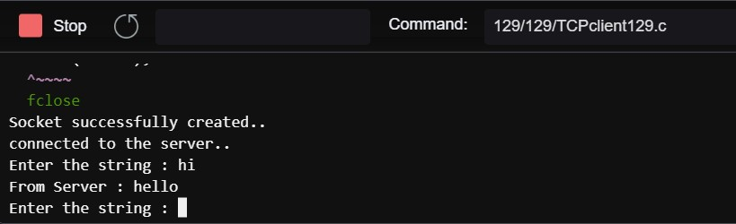

**Server Output:**

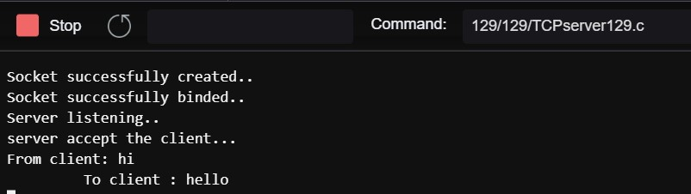

**Result:**

|  |  |
| --- | --- |
| **Ex.No:3** | **UDP ECHO CLIENT SERVER COMMUNICATION** |
| **Date:** |

**Aim:**

**METHODOLOGY:**

**Server:**

**Client:**

Source Code:

Server:

#include <stdio.h> #include <stdlib.h> #include <unistd.h> #include <string.h> #include <sys/types.h> #include <sys/socket.h> #include <arpa/inet.h> #include <netinet/in.h> #define PORT 2002

#define MAXLINE 1024

int main() {

int sockfd;

char buffer[MAXLINE];

char *hello = "Hello from server"; struct sockaddr_in servaddr, cliaddr;

if ( (sockfd = socket(AF_INET, SOCK_DGRAM, 0)) < 0 ) { perror("socket creation failed"); exit(EXIT_FAILURE);

}

memset(&servaddr, 0, sizeof(servaddr));

memset(&cliaddr, 0, sizeof(cliaddr)); servaddr.sin_family = AF_INET; servaddr.sin_addr.s_addr = INADDR_ANY; servaddr.sin_port = htons(PORT);

if ( bind(sockfd, (const struct sockaddr *)&servaddr, sizeof(servaddr)) < 0 )

{

perror("bind failed"); exit(EXIT_FAILURE);

}

int len, n;

len = sizeof(cliaddr);

n = recvfrom(sockfd, (char *)buffer, MAXLINE,MSG_WAITALL, ( struct sockaddr *) &cliaddr,&len);

buffer[n] = '\0';

printf("Client : %s\n", buffer);

sendto(sockfd, (const char *)hello, strlen(hello),MSG_CONFIRM, (const struct sockaddr *) &cliaddr,len);

printf("Hello message sent.\n"); return 0;

}

Client:

#include <stdio.h> #include <stdlib.h> #include <unistd.h> #include <string.h> #include <sys/types.h> #include <sys/socket.h> #include <arpa/inet.h> #include <netinet/in.h> #define PORT 2002

#define MAXLINE 1024

int main()

{

int sockfd;

char buffer[MAXLINE];

char *hello = "Hello from client"; struct sockaddr_in servaddr;

if ( (sockfd = socket(AF_INET, SOCK_DGRAM, 0)) < 0 ) { perror("socket creation failed"); exit(EXIT_FAILURE);

}

memset(&servaddr, 0, sizeof(servaddr)); servaddr.sin_family = AF_INET; servaddr.sin_port = htons(PORT); servaddr.sin_addr.s_addr = INADDR_ANY; int n, len;

sendto(sockfd, (const char *)hello, strlen(hello), MSG_CONFIRM, (const struct sockaddr *) &servaddr, sizeof(servaddr));

printf("Hello message sent.\n");

n = recvfrom(sockfd, (char *)buffer, MAXLINE, MSG_WAITALL, (struct sockaddr *) &servaddr, &len);

buffer[n] = '\0';

printf("Server : %s\n", buffer); close(sockfd);

return 0;

}

**Output:**

**CLIENT:**

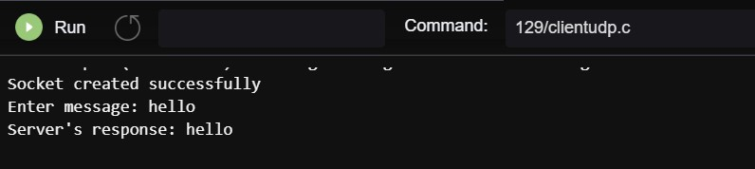

SERVER:

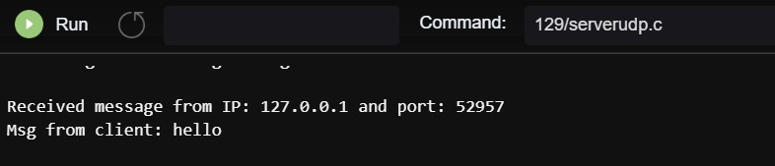

**Result:**

|  |  |
| --- | --- |
| **Ex.No:5** | **CONCURRENT TCP/IP DAY-TIME SERVER** |
| **Date:** |

**Aim:**

**METHODOLOGY:**

**Server :**

**Client :**

**Source Code:**

Server:

import socket import time

serversocket = socket.socket(socket.AF_INET, socket.SOCK_STREAM) host = socket.gethostname()

port = 9099 serversocket.bind((host, port)) serversocket.listen(5)

while True:

clientsocket,addr = serversocket.accept() print("Got a connection from %s" % str(addr)) currentTime = time.ctime(time.time()) + "\r\n" clientsocket.send(currentTime.encode('ascii')) clientsocket.close()

Client:

import socket

s = socket.socket(socket.AF_INET, socket.SOCK_STREAM) host = socket.gethostname()

port = 9099 s.connect((host, port)) tm = s.recv(1024)

s.close()

print("The time got from the server is %s" % tm.decode('ascii'))

Output:

CLIENT:

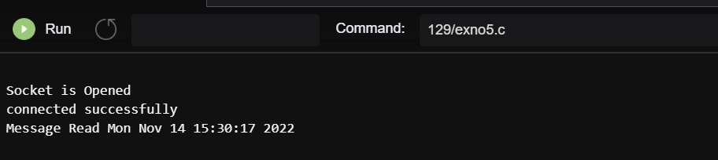

SERVER:

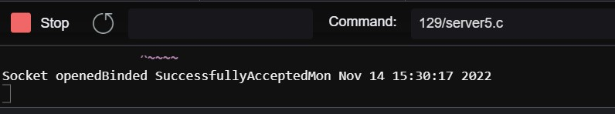

**Result :**

|  |  |
| --- | --- |
| **Ex.No:6** | **HALF DUPLEX CHAT USING TCP/IP** |
| **Date:** |

**Aim :**

**Methodlogy: Server:**

**Client:**

Source Code:

Server:

from socket import * server_port = 6500

server_socket = socket(AF_INET,SOCK_STREAM) server_socket.bind(('',server_port)) server_socket.listen(1)

print ("Welcome: The server is now ready to receive") connection_socket, address = server_socket.accept() while True:

sentence = connection_socket.recv(2048).decode() print('>> ',sentence)

message = input(">> ") connection_socket.send(message.encode()) if(message == 'Bye'): connectionSocket.close()

Client:

from socket import * server_name = 'localhost' server_port = 6500

client_socket = socket(AF_INET, SOCK_STREAM) client_socket.connect((server_name,server_port))

while True:

sentence = input(">> ") client_socket.send(sentence.encode()) message = client_socket.recv(2048) print (">> ", message.decode()) if(sentence == 'Bye'): client_socket.close()

Output:

CLIENT

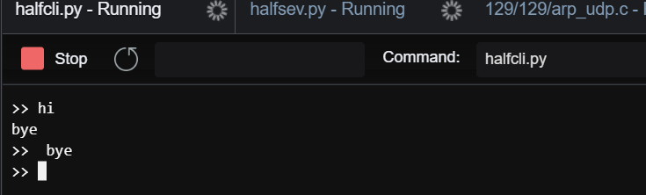

SERVER

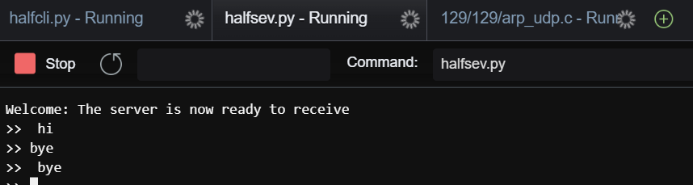

**Result :**

|  |  |
| --- | --- |
| **Ex.No:7** | **FULL DUPLEX CHAT USING TCP/IP** |
| **Date:** |

**Aim:**

Methodology: Server:

Client:

**Source Code:**

**Server:**

**#include <stdio.h> #include <netdb.h> #include <netinet/in.h> #include <stdlib.h> #include <string.h> #include <sys/socket.h> #include <sys/types.h> #define MAX 80**

**#define PORT 8080 #define SA struct sockaddr**

**void func(int connfd)**

**{**

**char buff[MAX]; int n;**

**for (;;) { bzero(buff, MAX);**

**read(connfd, buff, sizeof(buff)); printf("From client: %s\t To client : ", buff); bzero(buff, MAX);**

**n = 0;**

**while ((buff[n++] = getchar()) != '\n')**

**;**

**write(connfd, buff, sizeof(buff));**

**if (strncmp("exit", buff, 4) == 0) { printf("Server Exit...\n");**

**break;**

**}**

**}**

**}**

**int main()**

**{**

**int sockfd, connfd, len;**

**struct sockaddr_in servaddr, cli;**

**sockfd = socket(AF_INET, SOCK_STREAM, 0);**

**if (sockfd == -1) {**

**printf("socket creation failed...\n"); exit(0);**

**}**

**else**

**printf("Socket successfully created..\n"); bzero(&servaddr, sizeof(servaddr));**

**servaddr.sin_family = AF_INET; servaddr.sin_addr.s_addr = htonl(INADDR_ANY); servaddr.sin_port = htons(PORT);**

**if ((bind(sockfd, (SA*)&servaddr, sizeof(servaddr))) != 0) { printf("socket bind failed...\n");**

**exit(0);**

**}**

**else**

**printf("Socket successfully binded..\n");**

**if ((listen(sockfd, 5)) != 0) { printf("Listen failed...\n"); exit(0);**

**}**

**else**

**printf("Server listening..\n"); len = sizeof(cli);**

**connfd = accept(sockfd, (SA*)&cli, &len); if (connfd < 0) {**

**printf("server accept failed...\n"); exit(0);**

**}**

**else**

**printf("server accept the client...\n"); func(connfd);**

**close(sockfd);**

**}**

**Client:**

**#include <arpa/inet.h> #include <netdb.h> #include <stdio.h> #include <stdlib.h> #include <string.h> #include <strings.h> #include <sys/socket.h> #include <unistd.h> #define MAX 80**

**#define PORT 8080 #define SA struct sockaddr**

**void func(int sockfd)**

**{**

**char buff[MAX]; int n;**

**for (;;) {**

**bzero(buff, sizeof(buff)); printf("Enter the string : "); n = 0;**

**while ((buff[n++] = getchar()) != '\n')**

**;**

**write(sockfd, buff, sizeof(buff)); bzero(buff, sizeof(buff)); read(sockfd, buff, sizeof(buff)); printf("From Server : %s", buff); if ((strncmp(buff, "exit", 4)) == 0) {**

**printf("Client Exit...\n"); break;**

**}**

**}**

**}**

**int main()**

**{**

**int sockfd, connfd;**

**struct sockaddr_in servaddr, cli;**

**sockfd = socket(AF_INET, SOCK_STREAM, 0); if (sockfd == -1) {**

**printf("socket creation failed...\n"); exit(0);**

**}**

**else**

**printf("Socket successfully created..\n"); bzero(&servaddr, sizeof(servaddr));**

**servaddr.sin_family = AF_INET; servaddr.sin_addr.s_addr = inet_addr("127.0.0.1"); servaddr.sin_port = htons(PORT);**

**if (connect(sockfd, (SA*)&servaddr, sizeof(servaddr))**

**!= 0) {**

**printf("connection with the server failed...\n"); exit(0);**

**}**

**else**

**printf("connected to the server..\n"); func(sockfd);**

**close(sockfd);**

**}**

**Output:**

CLIENT:

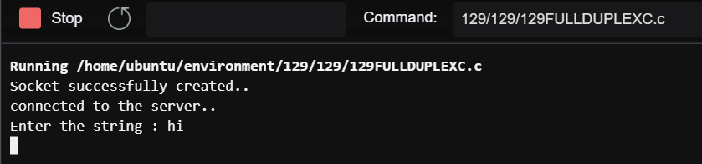

SERVER:

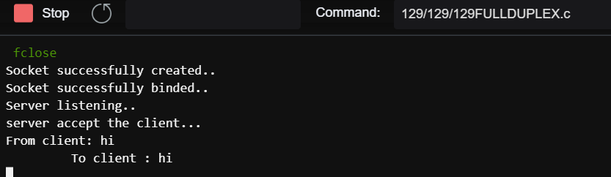

**Result:**

|  |  |
| --- | --- |
| **Ex.No:8** | **IMPLEMENTATION OF FILE TRANSFER PROTOCOL** |
| **Date:** |

**Aim :**

**METHODOLOGY:**

Server :

Client :

Source Code:

Server: #include<stdio.h> #include<arpa/inet.h> #include<sys/types.h> #include<sys/socket.h> #include<netinet/in.h> #include<netdb.h> #include<stdlib.h> #include<string.h> #include<unistd.h>

#define SERV_TCP_PORT 5035

#define MAX 60 int i, j, tem;

char buff[4096], t; FILE *f1;

int main(int afg, char *argv)

{

int sockfd, newsockfd, clength;

struct sockaddr_in serv_addr,cli_addr; char t[MAX], str[MAX]; strcpy(t,"exit");

sockfd=socket(AF_INET, SOCK_STREAM,0); serv_addr.sin_family=AF_INET; serv_addr.sin_addr.s_addr=INADDR_ANY; serv_addr.sin_port=htons(SERV_TCP_PORT); printf("\nBinded");

bind(sockfd,(struct sockaddr*)&serv_addr, sizeof(serv_addr)); printf("\nListening...");

listen(sockfd, 5); clength=sizeof(cli_addr);

newsockfd=accept(sockfd,(struct sockaddr*) &cli_addr,&clength); close(sockfd);

read(newsockfd, &str, MAX);

printf("\nClient message\n File Name : %s\n", str); f1=fopen(str, "r");

while(fgets(buff, 4096, f1)!=NULL)

{

write(newsockfd, buff,MAX); printf("\n");

}

fclose(f1);

printf("\nFile Transferred\n"); return 0;

}

Client: #include<stdio.h> #include<sys/types.h> #include<sys/socket.h> #include<netinet/in.h> #include<netdb.h> #include<stdlib.h> #include<string.h> #include<unistd.h>

#define SERV_TCP_PORT 5035

#define MAX 60

int main(int arg,char*argv[])

{

int sockfd,n;

struct sockaddr_in serv_addr; struct hostent*server;

char send[MAX],recvline[MAX],s[MAX],name[MAX]; sockfd=socket(AF_INET,SOCK_STREAM,0); serv_addr.sin_family=AF_INET; serv_addr.sin_addr.s_addr=inet_addr("127.0.0.1"); serv_addr.sin_port=htons(SERV_TCP_PORT); connect(sockfd,(struct sockaddr*)&serv_addr,sizeof(serv_addr)); printf("\nEnter the source file name : \n");

scanf("%s",send); write(sockfd,send,MAX); while((n=read(sockfd,recvline,MAX))!=0)

{

printf("%s",recvline);

}

close(sockfd); return 0;

}

Output:

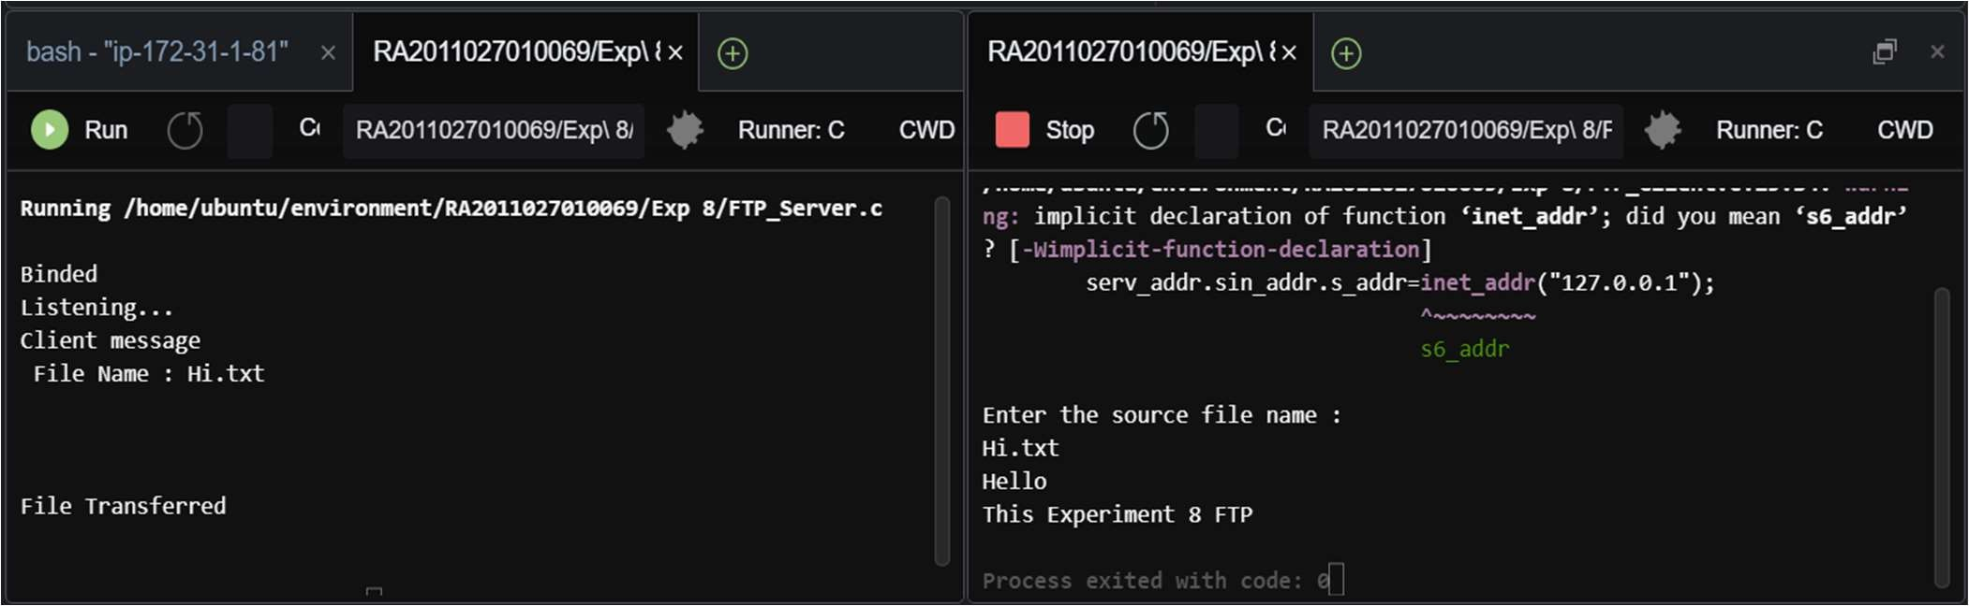

Result:

|  |  |
| --- | --- |
| **Ex.No:9** | **REMOTE COMMAND EXECUTION USING UDP** |
| **Date:** |

**Aim:**

**METHODOLOGY:**

**Server:**

·

Client:

Source Code:

Server:

#include<sys/types.h> #include<sys/socket.h> #include<stdio.h> #include<netdb.h> #include<netinet/in.h> #include<string.h> #include<sys/stat.h> #include<arpa/inet.h> #include<unistd.h>

int main(int argc,char* argv[])

{

int sd,size;

char buff[1024],file[10000];

struct sockaddr_in cliaddr,servaddr; FILE *fp;

struct stat x; socklen_t clilen; clilen=sizeof(cliaddr);

bzero(&servaddr,sizeof(servaddr)); servaddr.sin_family=AF_INET; servaddr.sin_addr.s_addr=htonl(INADDR_ANY); servaddr.sin_port=htons(9976); sd=socket(AF_INET,SOCK_DGRAM,0);

if(sd<0)

{

printf("Socket CReation Error");

}

bind(sd,(struct sockaddr *)&servaddr,sizeof(servaddr)); while(1)

{

bzero(buff,sizeof(buff));

recvfrom(sd,buff,sizeof(buff),0,(struct sockaddr *)&cliaddr,&clilen); strcat(buff,">Hi.text");

system(buff); fp=fopen("Hi.text","r");

stat("Hi.text",&x); size=x.st_size; fread(file,size,1,fp);

sendto(sd,file,sizeof(file),0,(struct sockaddr *)&cliaddr,sizeof(cliaddr)); printf("Data Sent to UDPCLIENT %s",buff);

}

close(sd); return 0;

}

Client:

#include<sys/types.h> #include<sys/socket.h> #include<stdio.h> #include<unistd.h> #include<netdb.h> #include<netinet/in.h> #include<string.h> #include<arpa/inet.h> #include<sys/stat.h>

int main(int argc,char* argv[])

{

int sd;

char buff[1024],file[10000];

struct sockaddr_in cliaddr,servaddr; struct hostent *h;

socklen_t servlen; servlen=sizeof(servaddr); h=gethostbyname(argv[1]); bzero(&servaddr,sizeof(servaddr)); servaddr.sin_family=h->h_addrtype;

memcpy((char *)&servaddr.sin_addr,h->h_addr_list[0],h->h_length); servaddr.sin_port=htons(9976); sd=socket(AF_INET,SOCK_DGRAM,0);

if(sd<0)

{

printf("Socket CReation Error");

}

bind(sd,(struct sockaddr *)&servaddr,sizeof(servaddr)); while(1)

{

printf("\nEnter the command to be executed"); fgets(buff,1024,stdin);

sendto(sd,buff,strlen(buff)+1,0,(struct sockaddr *)&servaddr,sizeof(servaddr)); printf("\nData Sent");

recvfrom(sd,file,strlen(file)+1,0,(struct sockaddr *)&servaddr,&servlen); printf("Recieved From UDPSERVER %s",file);

}

return 0;

}

Output:

Server:

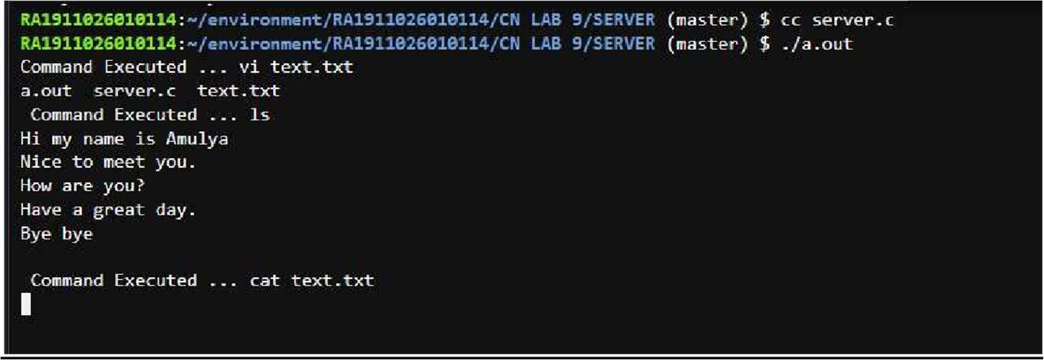

Client:

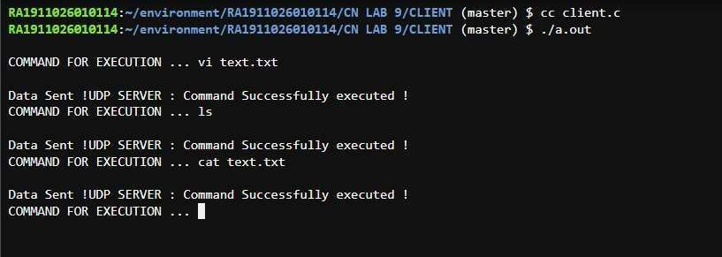

Result:

|  |  |
| --- | --- |
| **Ex.No:10** | **ARP IMPLEMENTATION USING UDP** |
| **Date:** |

**Aim :**

**METHODOLOGY:**

Source Code:

#include<sys/types.h> #include<sys/socket.h> #include<net/if_arp.h> #include<sys/ioctl.h> #include<stdio.h> #include<string.h> #include<unistd.h> #include<math.h> #include<complex.h> #include<arpa/inet.h> #include<netinet/in.h> #include<netinet/if_ether.h> #include<net/ethernet.h> #include<stdlib.h>

int main()

{

struct sockaddr_in sin={0}; struct arpreq myarp={{0}}; unsigned char *ptr;

int sd; sin.sin_family=AF_INET; printf("Enter IP address: "); char ip[20];

scanf("%s", ip);

if(inet_pton(AF_INET,ip,&sin.sin_addr)==0)

{

printf("IP address Entered '%s' is not valid \n",ip); exit(0);

}

memcpy(&myarp.arp_pa,&sin,sizeof(myarp.arp_pa)); strcpy(myarp.arp_dev,"echo"); sd=socket(AF_INET,SOCK_DGRAM,0); printf("\nSend ARP request\n"); if(ioctl(sd,SIOCGARP,&myarp)==1)

{

printf("No Entry in ARP cache for '%s'\n",ip); exit(0);

}

ptr=&myarp.arp_pa.sa_data[0]; printf("Received ARP Reply\n"); printf("\nMAC Address for '%s' : ",ip);

printf("%p:%p:%p:%p:%p:%p\n",ptr,(ptr+1),(ptr+2),(ptr+3),(ptr+4),(ptr+5)); return 0;

}

**Output:**

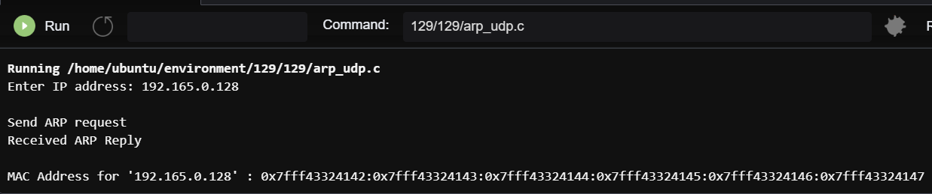

Result:

|  |  |
| --- | --- |
| **Ex.No:11** | **STUDY OF IPV6 ADDRESSING & SUBNETTING** |
| **Date:** |

**AIM:**

|  |  |
| --- | --- |
| **Ex.No:12** | **IMPLEMENTATION OF NETWORK ADDRESS TRANSLATION** |
| **Date:** |

**Aim:**

**Procedure:**

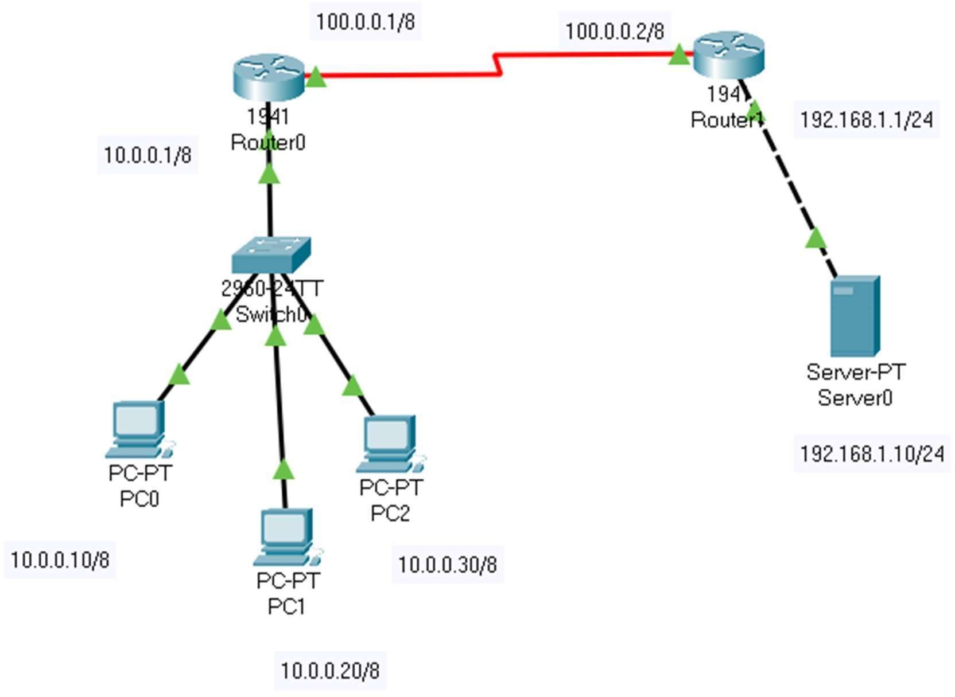

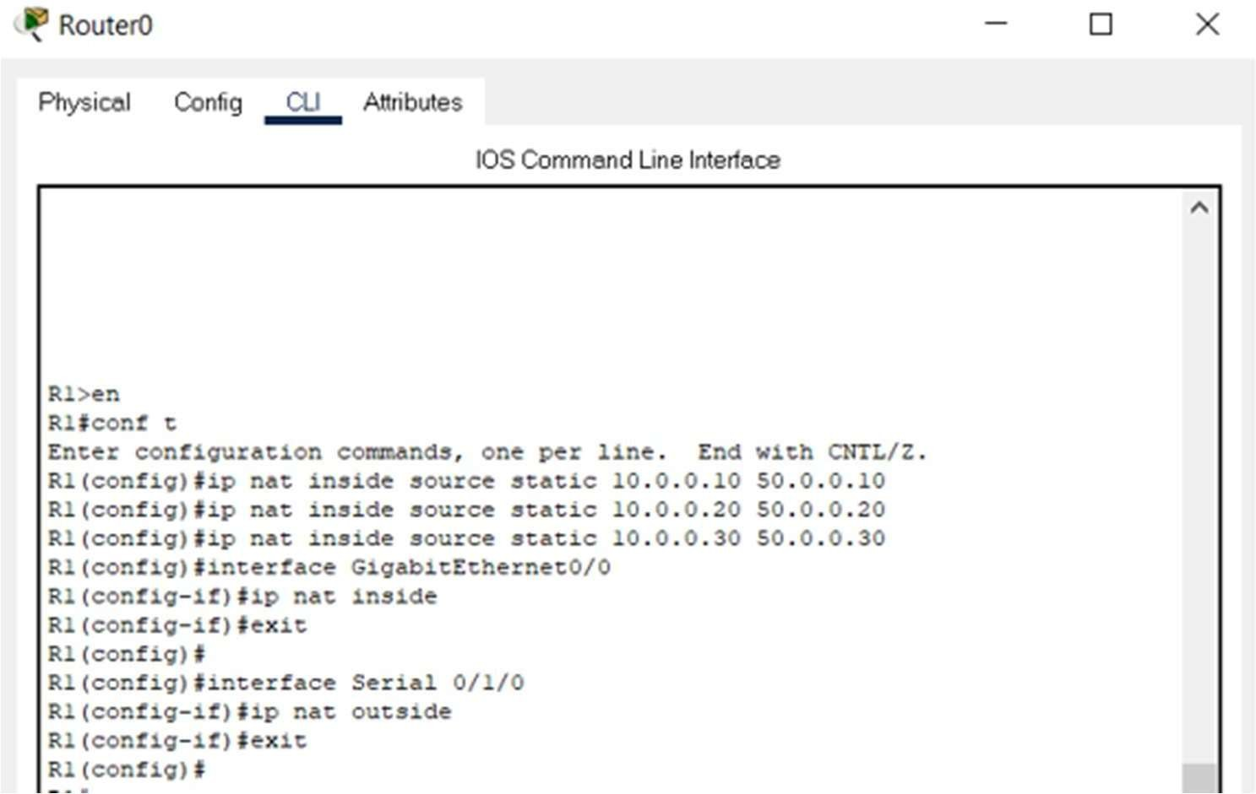

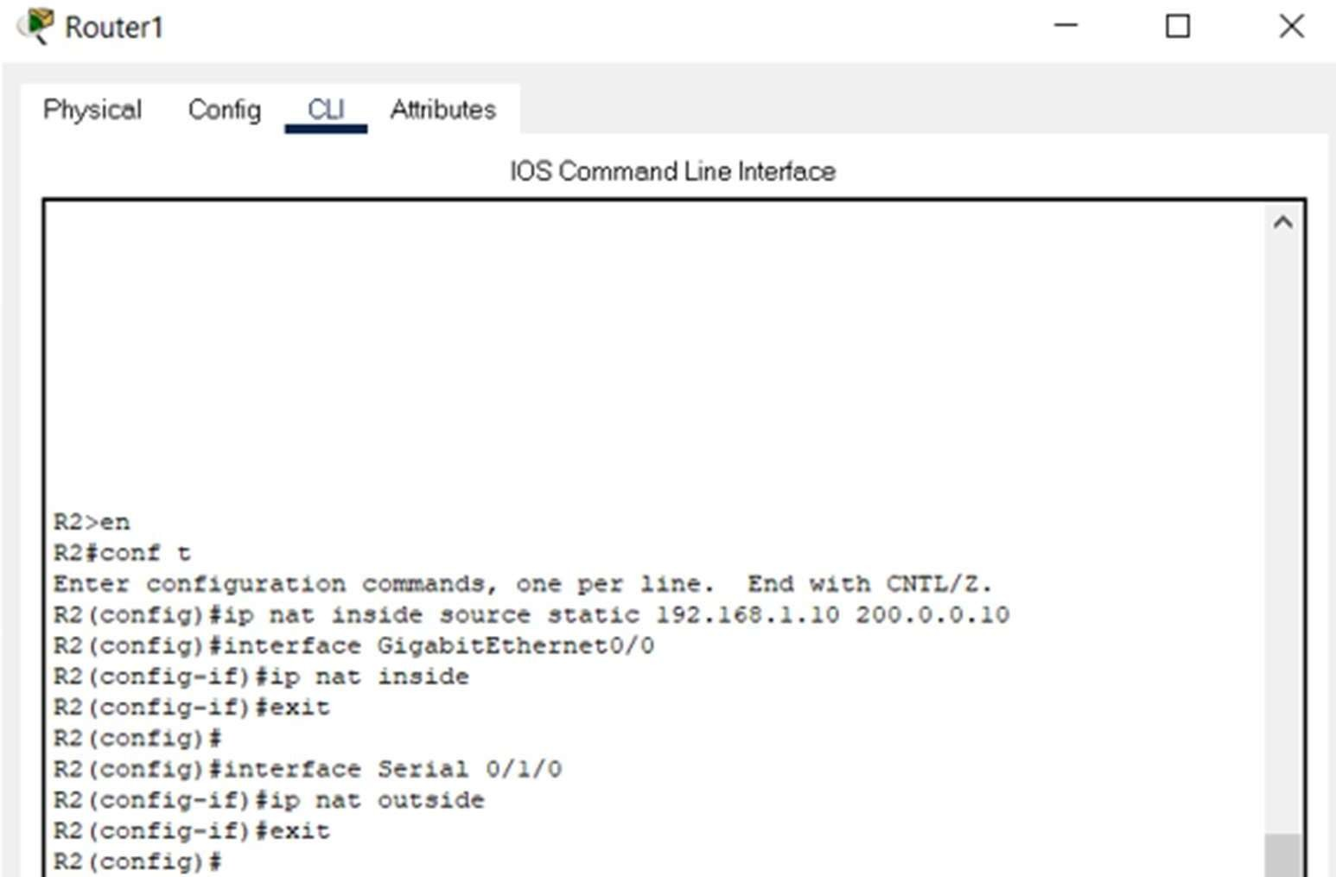

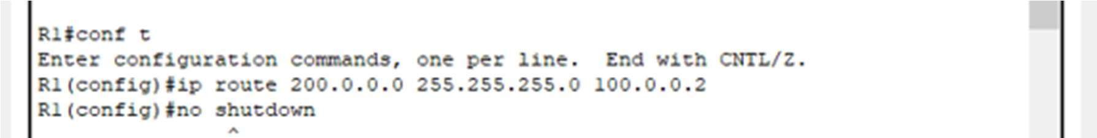

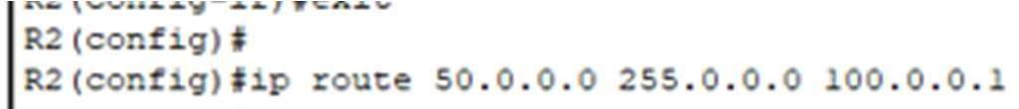

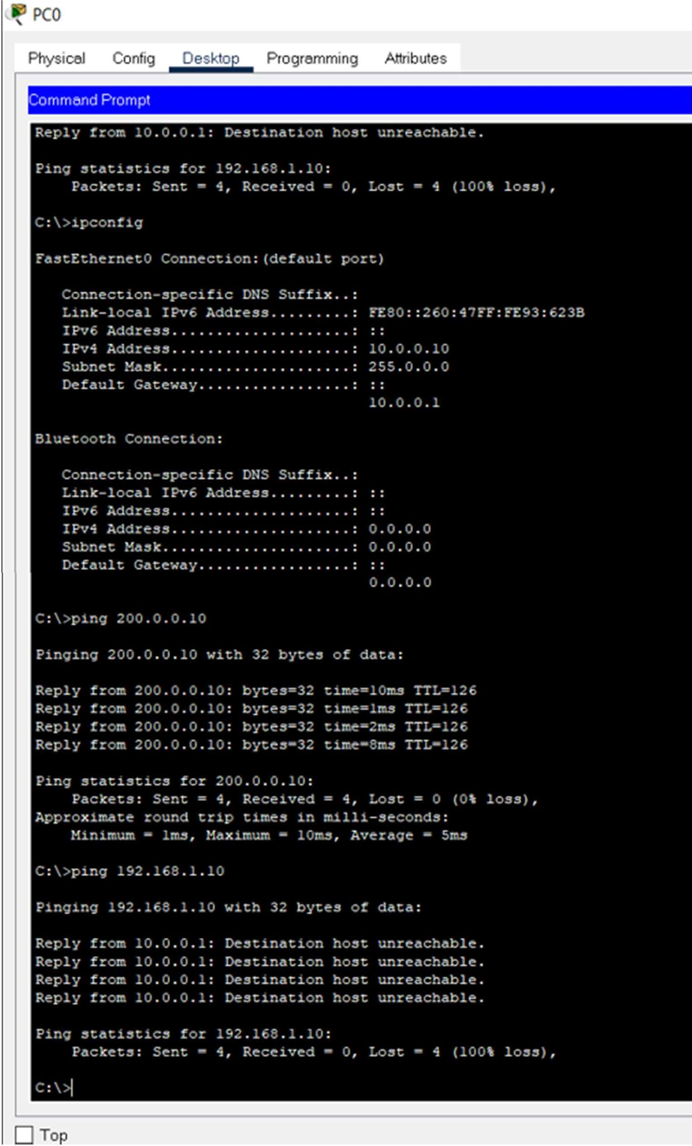

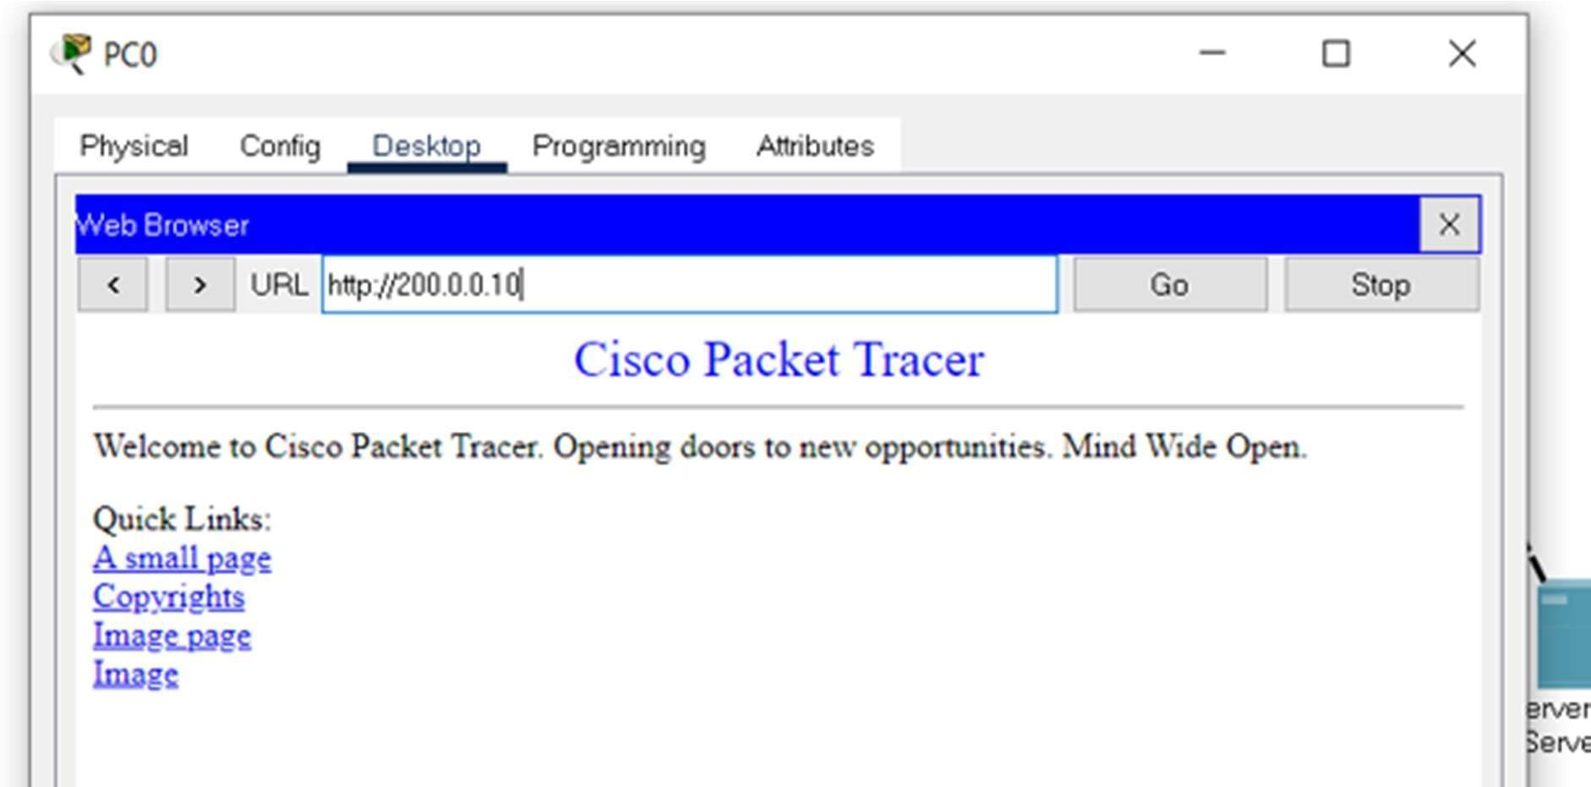

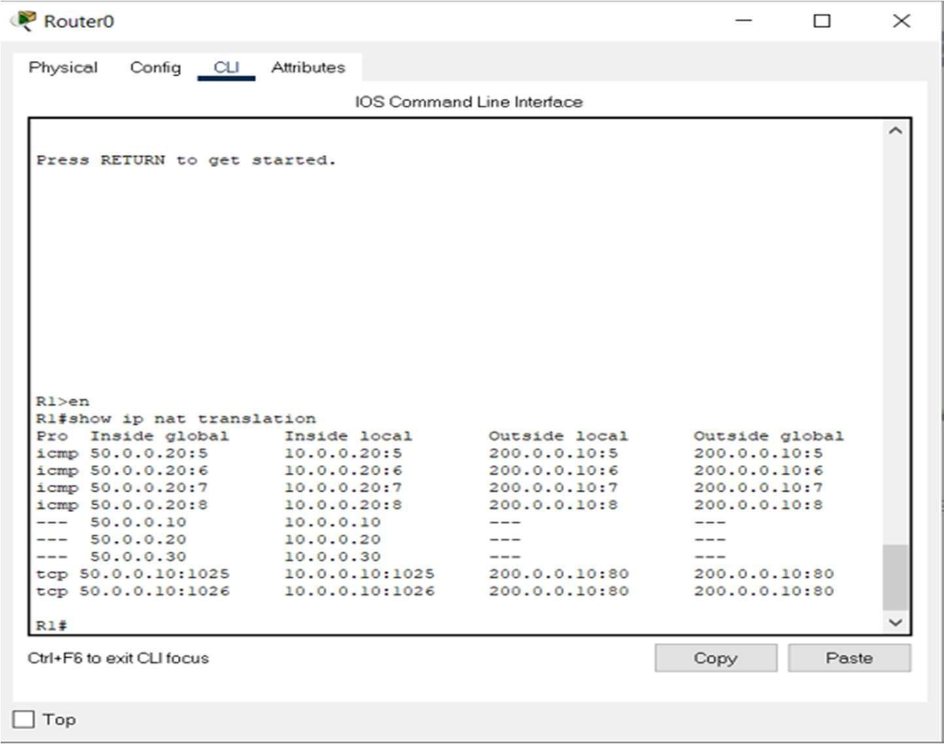

For router1:

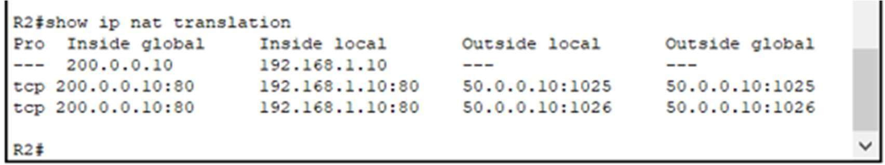

**Result:**

|  |  |
| --- | --- |
| **Ex.No:13** | **IMPLEMENTATION OF VPN** |
| **Date:** |

**AIM :**

**PROCEDURE :**

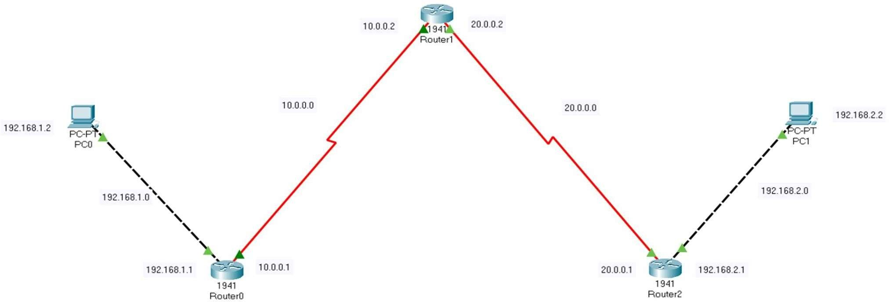

2 . Initial IP configuration.

|  |  |  |
| --- | --- | --- |
| **Device / Interface** | **IP Address** | **Connected with** |
|  |  |  |
|  |  |  |
|  |  |  |
|  |  |  |
|  |  |  |
|  |  |  |



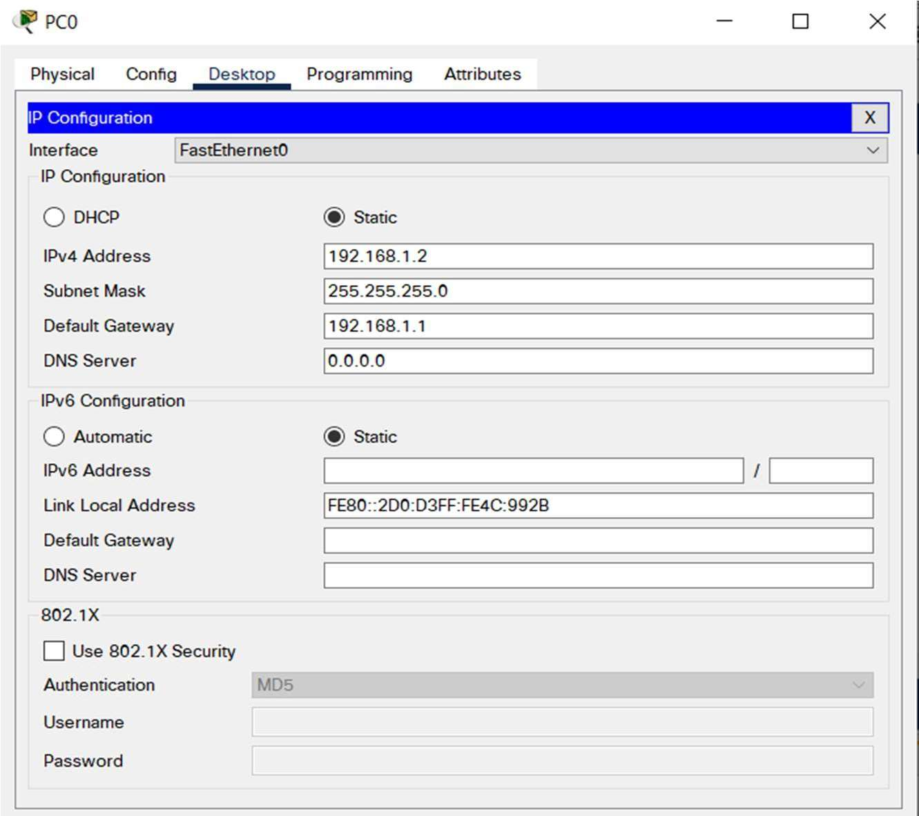

Router>enable Router#config t Router(config)#int gig0/0

Router(config-if)#ip add 192.168.1.1 255.255.255.0 Router(config-if)#no shut

Router(config-if)#exit Router(config)#int se0/1/0

Router(config-if)#ip address 10.0.0.1 255.0.0.0 Router(config-if)#no shut

Router>enable Router#config t Router(config)#int se0/1/0

Router(config-if)#ip add 10.0.0.2 255.0.0.0 Router(config-if)#no shut

Router(config-if)#exit Router(config)#int se0/1/1

Router(config-if)#ip add 20.0.0.1 255.0.0.0 Router(config-if)#no shut

CONFIGURATION ON ROUTER3:

Router>enable Router#config t Router(config)#int se0/1/0

Router(config-if)#ip add 20.0.0.2 255.0.0.0 Router(config-if)#no shut

Router(config-if)#exit Router(config)#int gig0/0

Router(config-if)#ip add 192.168.2.1 255.255.255.0 Router(config-if)#no shut



Router>enable Router#config t

Enter configuration commands, one per line. End with CNTL/Z. Router(config)#ip route 0.0.0.0 0.0.0.0 10.0.0.2 Router(config)#

Router>enable Router#config t

Enter configuration commands, one per line. End with CNTL/Z. Router(config)#ip route 0.0.0.0 0.0.0.0 20.0.0.1 Router(config)#

Now we go to Router3 and test the network by pinging Router1 interface.



Router#ping 20.0.0.2

Type escape sequence to abort.

Sending 5, 100-byte ICMP Echos to 20.0.0.2, timeout is 2 seconds:

!!!!!

Success rate is 100 percent (5/5), round-trip min/avg/max = 26/28/33 ms

Router#ping 10.0.0.1

Type escape sequence to abort.

Sending 5, 100-byte ICMP Echos to 10.0.0.1, timeout is 2 seconds:

!!!!!



Success rate is 100 percent (5/5), round-trip min/avg/max = 25/28/32 ms

You can clearly see both routers pinging each other successfully.



Router#config t Router(config)#interface tunnel 200

Router(config-if)#ip address 172.18.1.1 255.255.0.0 Router(config-if)#tunnel source se0/1/0 Router(config-if)#tunnel destination 20.0.0.2 Router(config-if)#no shut

Router#config t Router(config)#interface tunnel 400

Router(config-if)#ip address 172.18.1.2 255.255.0.0 Router(config-if)#tunnel source se0/1/0 Router(config-if)#tunnel destination 10.0.0.1 Router(config-if)#no shut

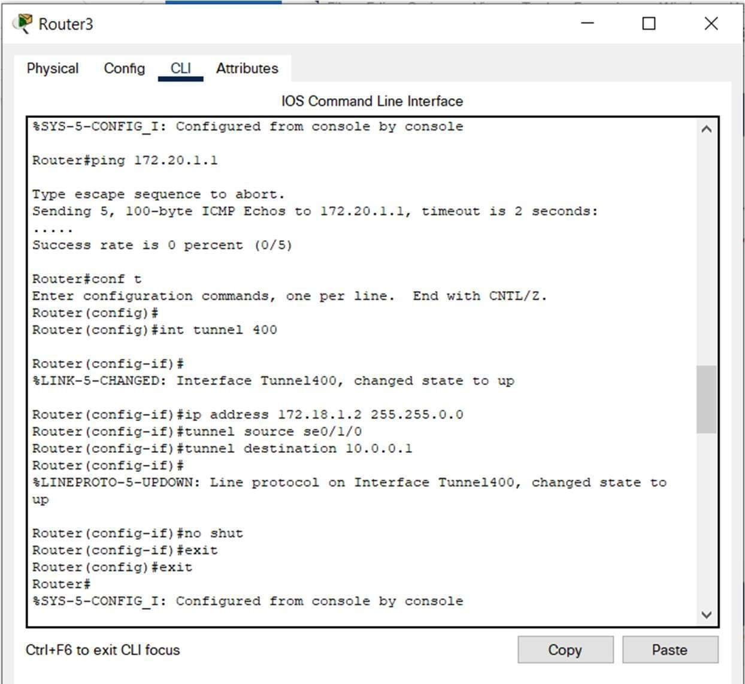

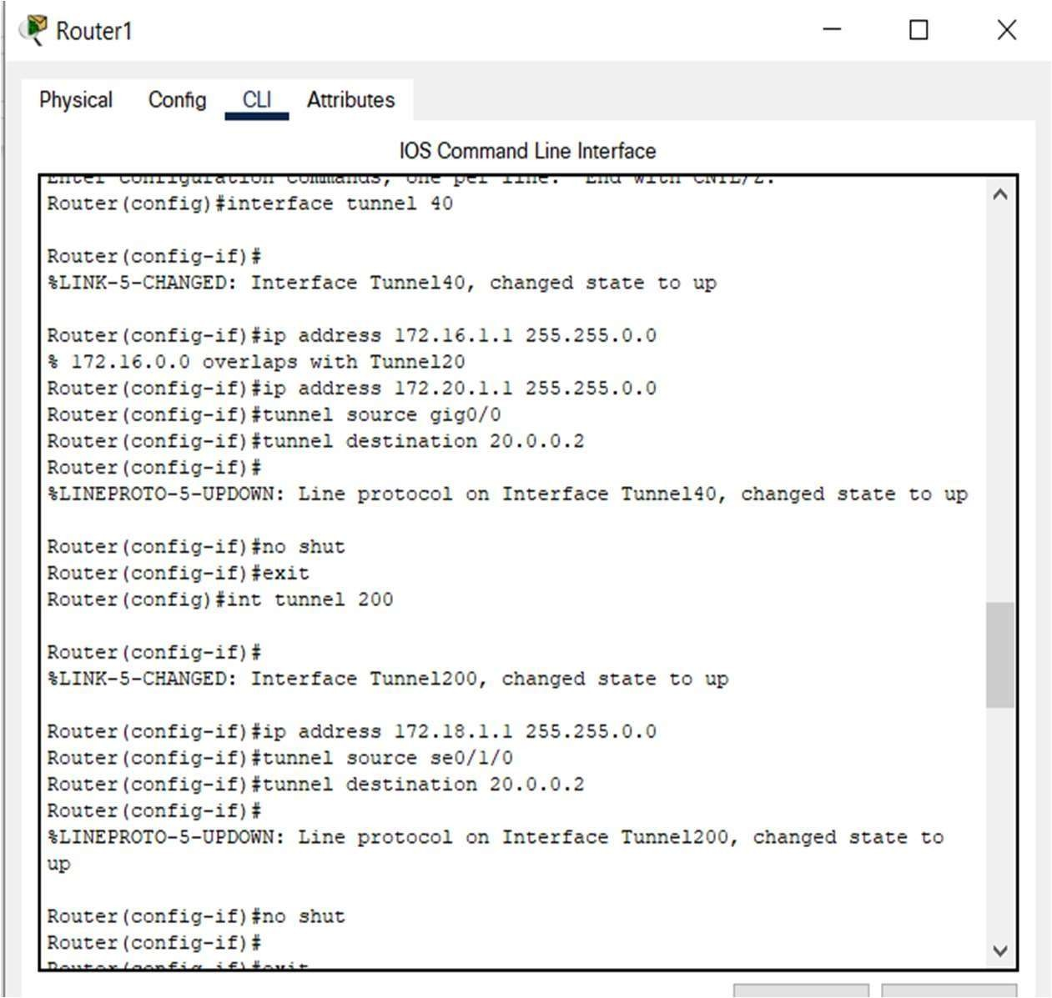



8.

Router1



Router#ping 172.18.1.2

Type escape sequence to abort.

Sending 5, 100-byte ICMP Echos to 172.18.1.2, timeout is 2 seconds:

!!!!!

Success rate is 100 percent (5/5), round-trip min/avg/max = 30/32/36 ms Router#

Router2

Router#ping 172.18.1.1

Type escape sequence to abort.

Sending 5, 100-byte ICMP Echos to 172.18.1.1, timeout is 2 seconds:

!!!!!

Success rate is 100 percent (5/5), round-trip min/avg/max = 33/45/83 ms

Router(config)#ip route 192.168.2.0 255.255.255.0 172.18.1.2

Router(config)#ip route 192.168.1.0 255.255.255.0 172.18.1.1

Router#show interfaces Tunnel 200

Tunnel200 is up, line protocol is up (connected) Hardware is Tunnel

Internet address is 172.18.1.1/16

MTU 17916 bytes, BW 100 Kbit/sec, DLY 50000 usec, reliability 255/255, txload 1/255, rxload 1/255 Encapsulation TUNNEL, loopback not set

Keepalive not set

Tunnel source 10.0.0.1 (FastEthernet0/1), destination 20.0.0.2 Tunnel protocol/transport GRE/IP

Key disabled, sequencing disabled Checksumming of packets disabled Tunnel TTL 255

Fast tunneling enabled

Tunnel transport MTU 1476 bytes Tunnel transmit bandwidth 8000 (kbps) Tunnel receive bandwidth 8000 (kbps)

Last input never, output never, output hang never Last clearing of "show interface" counters never

Input queue: 0/75/0/0 (size/max/drops/flushes); Total output drops: 1 Queueing strategy: fifo

Output queue: 0/0 (size/max)

5 minute input rate 32 bits/sec, 0 packets/sec

5 minute output rate 32 bits/sec, 0 packets/sec

52 packets input, 3508 bytes, 0 no buffer

Received 0 broadcasts, 0 runts, 0 giants, 0 throttles

0 input errors, 0 CRC, 0 frame, 0 overrun, 0 ignored, 0 abort 0 input packets with dribble condition detected

52 packets output, 3424 bytes, 0 underruns

0 output errors, 0 collisions, 0 interface resets

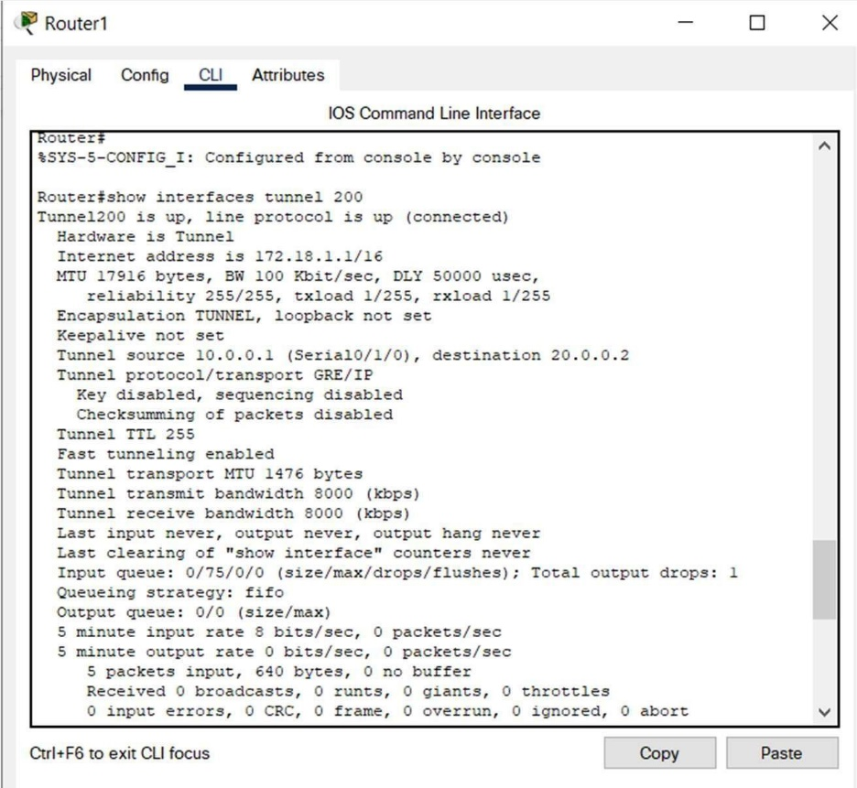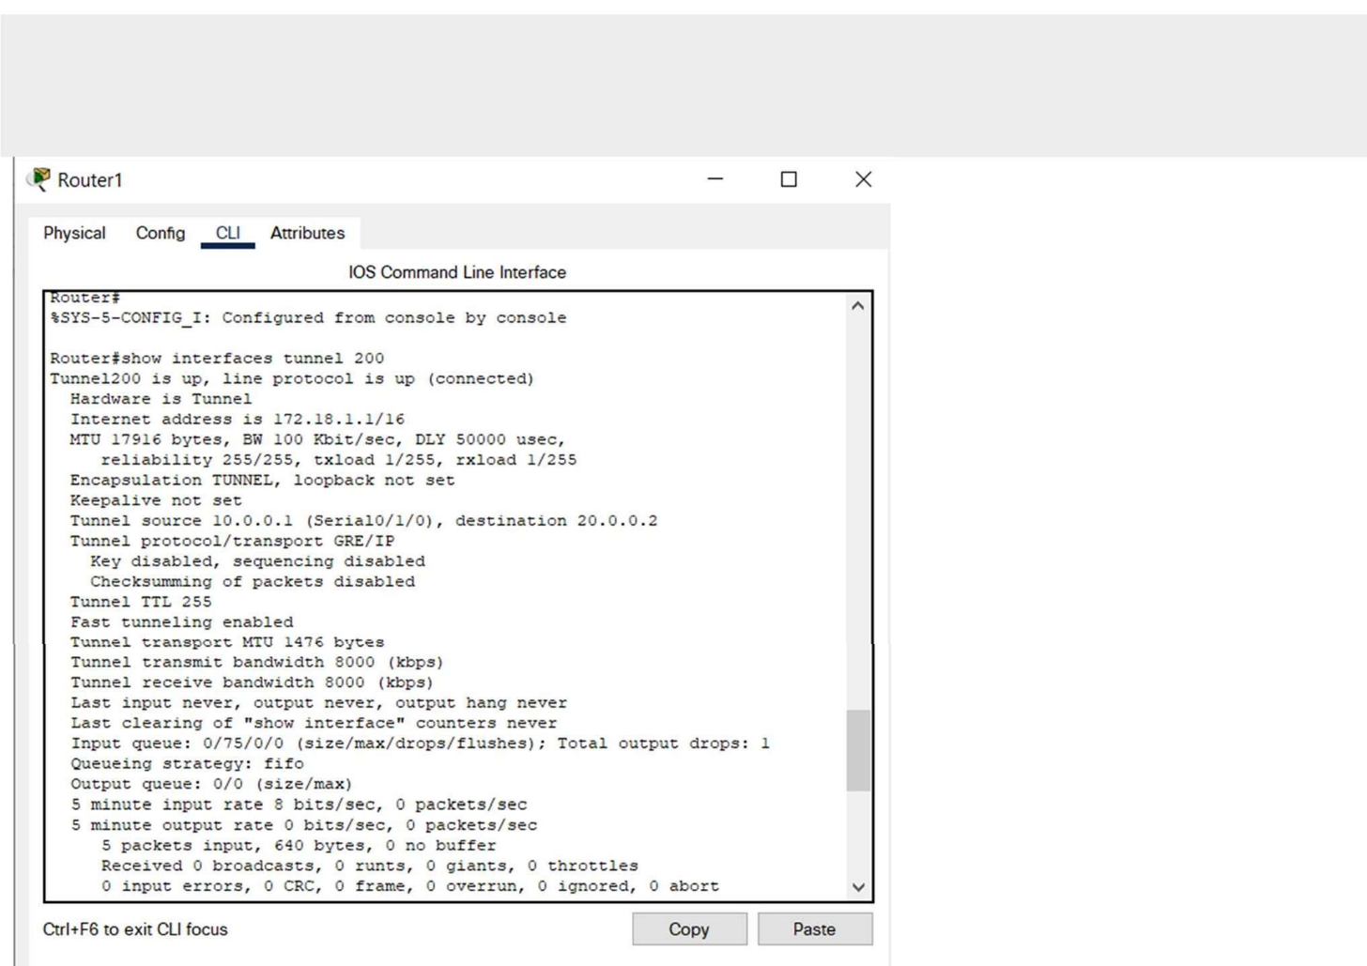

0 unknown protocol drops

0 output buffer failures, 0 output buffers swapped out

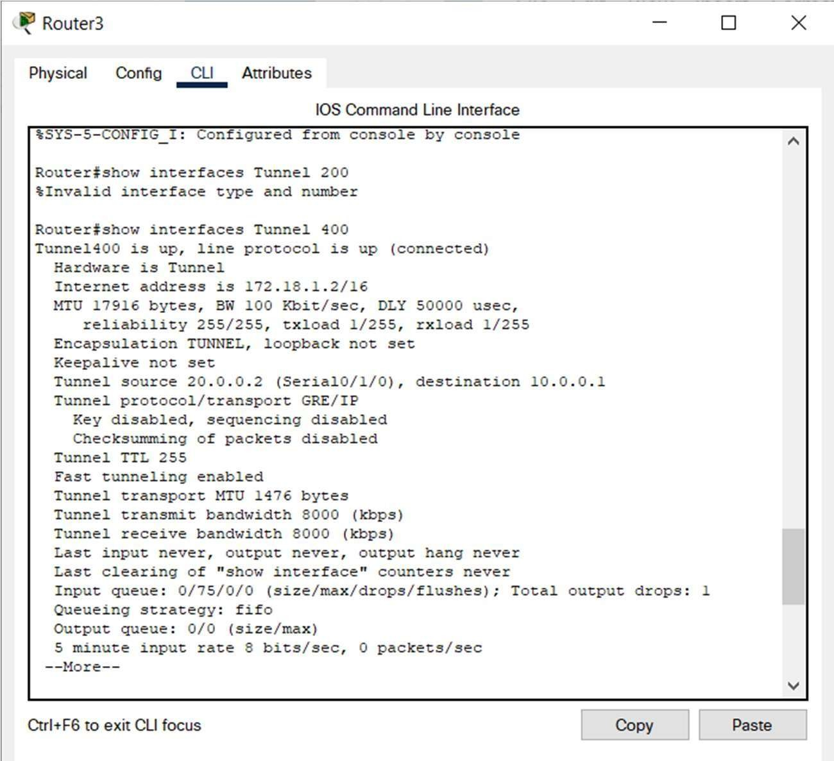

Now going to Router3 and test VPN Tunnel Creation: Router #show interface Tunnel 400

Tunnel400 is up, line protocol is up (connected) Hardware is Tunnel

Internet address is 172.18.1.2/16

MTU 17916 bytes, BW 100 Kbit/sec, DLY 50000 usec, reliability 255/255, txload 1/255, rxload 1/255 Encapsulation TUNNEL, loopback not set

Keepalive not set

Tunnel source 20.0.0.2 (FastEthernet0/0), destination 10.0.0.1 Tunnel protocol/transport GRE/IP

Key disabled, sequencing disabled Checksumming of packets disabled Tunnel TTL 255

Fast tunneling enabled

Tunnel transport MTU 1476 bytes Tunnel transmit bandwidth 8000 (kbps) Tunnel receive bandwidth 8000 (kbps)

Last input never, output never, output hang never Last clearing of "show interface" counters never

Input queue: 0/75/0/0 (size/max/drops/flushes); Total output drops: 1 Queueing strategy: fifo

Output queue: 0/0 (size/max)

5 minute input rate 32 bits/sec, 0 packets/sec



5 minute output rate 32 bits/sec, 0 packets/sec

52 packets input, 3424 bytes, 0 no buffer

Received 0 broadcasts, 0 runts, 0 giants, 0 throttles

0 input errors, 0 CRC, 0 frame, 0 overrun, 0 ignored, 0 abort 0 input packets with dribble condition detected

53 packets output, 3536 bytes, 0 underruns

0 output errors, 0 collisions, 0 interface resets 0 unknown protocol drops

11. Trace the VPN tunnel path.

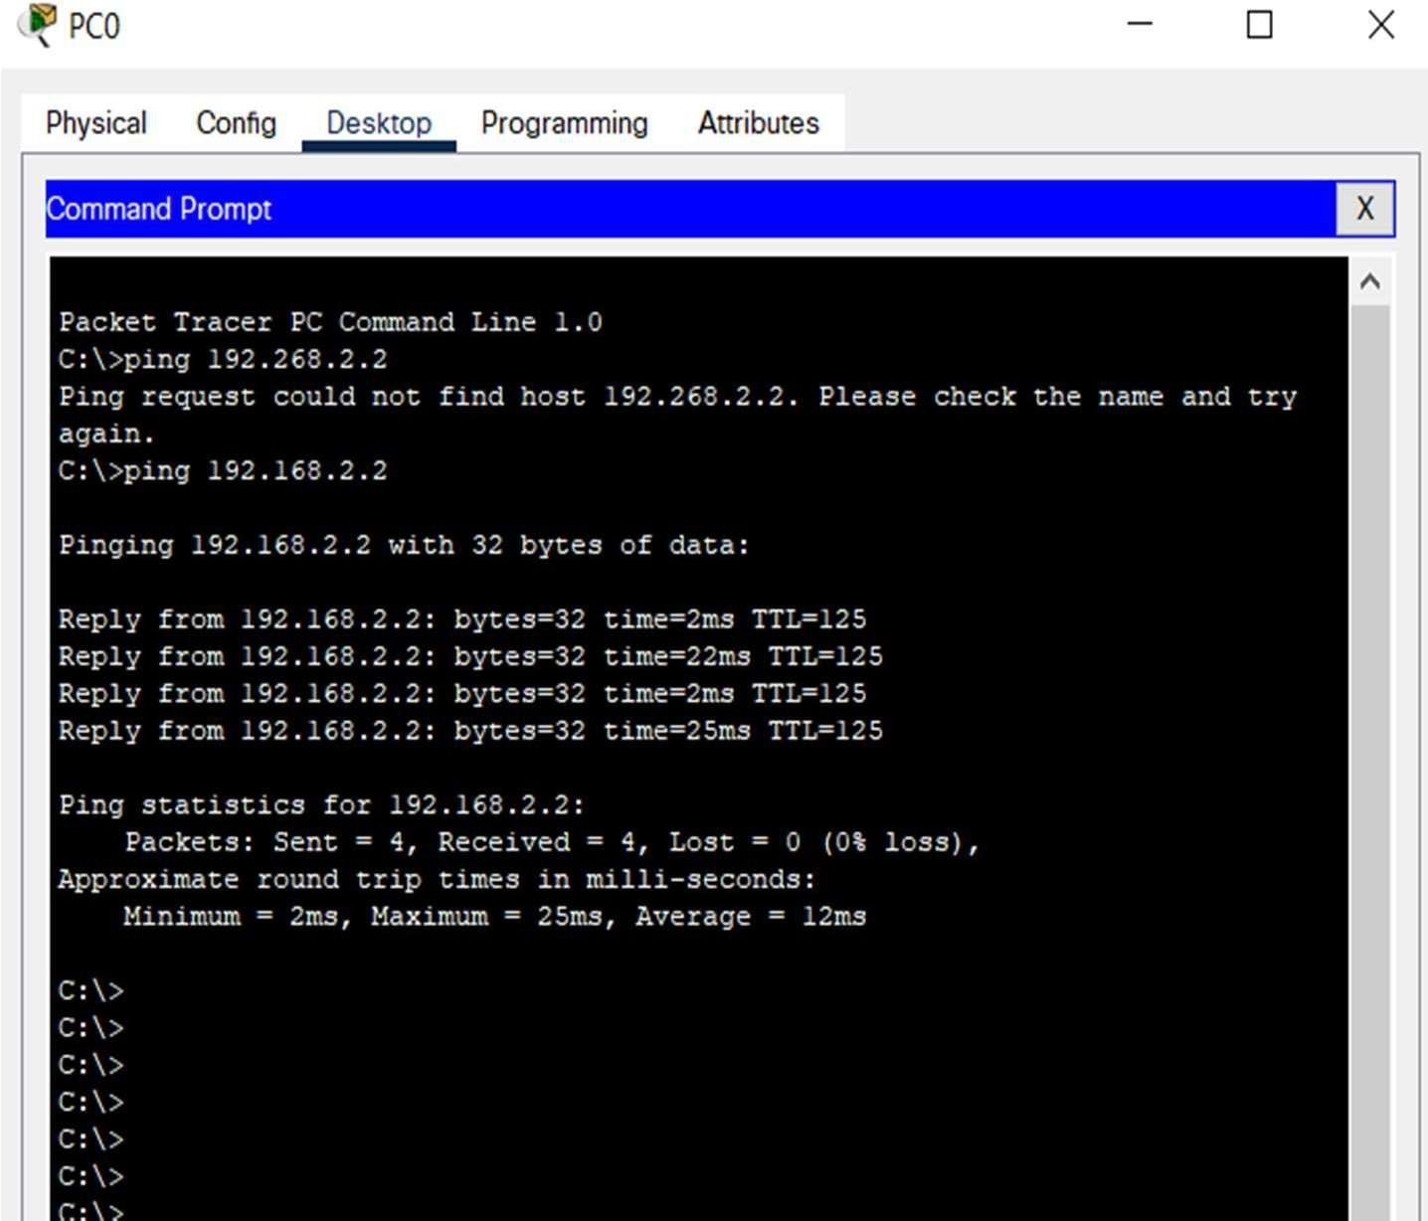

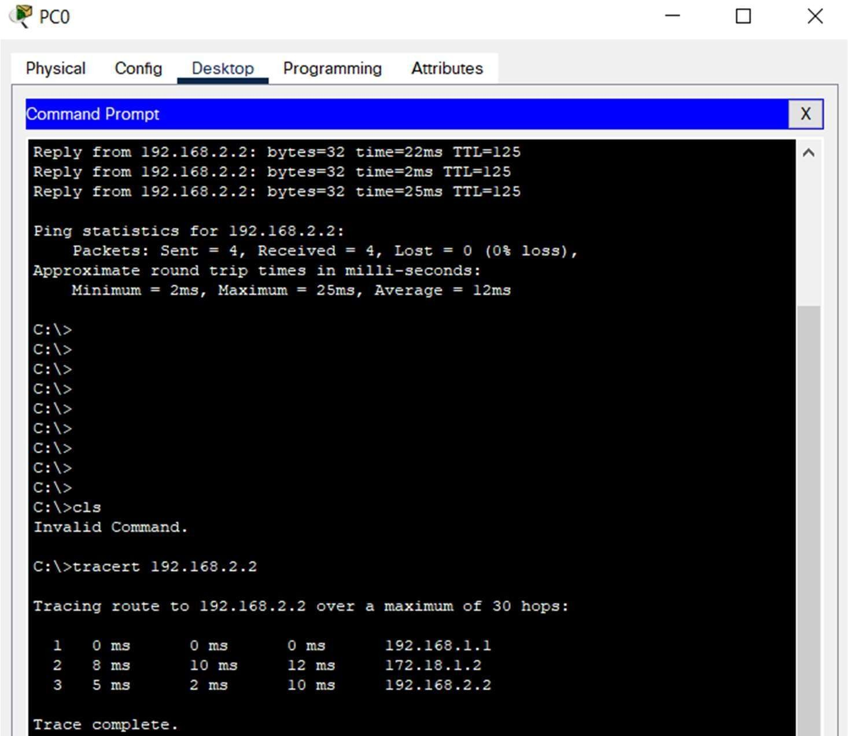

**RESULT:**

|  |  |
| --- | --- |
| **Ex.No:14** | **COMMUNICATION USING HDLC** |
| **Date:** |

**AIM:**

**PROCEDURE:**

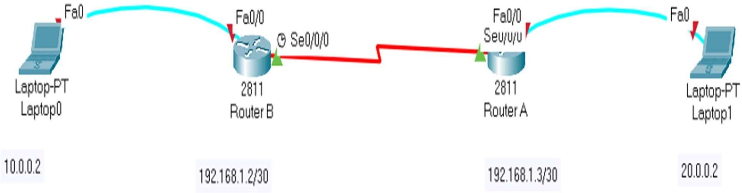

2 . Initial IP configuration.

|  |  |  |
| --- | --- | --- |
| **Device / Interface** | **IP Address** | **Connected with** |
| PC0 / Fa0 | 10.0.0.2 /8 | Router0 / Fa0/0 |
| PC1 / Fa0 | 20.0.0.2 /8 | Router1 / Fa0/0 |
| Router0 / Se0/3/0 | 192.168.1.2 /30 | Router1 / Se0/3/0 |
| Router1 / Se0/3/0 | 192.168.1.3 /30 | Router0 / Se0/3/0 |

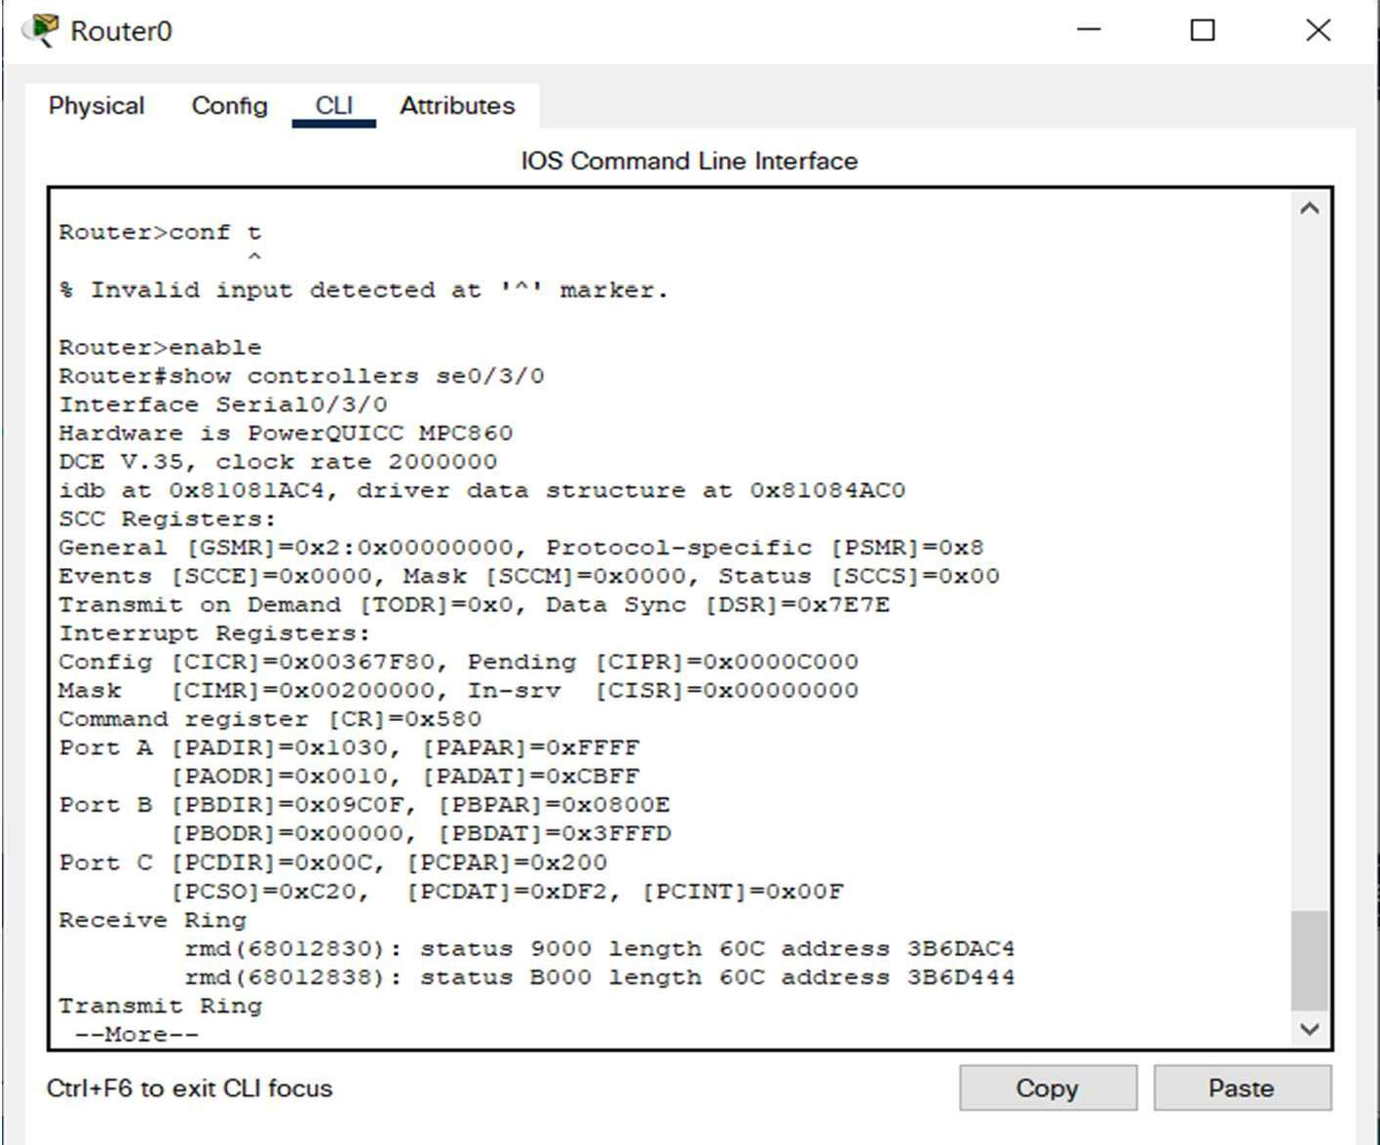

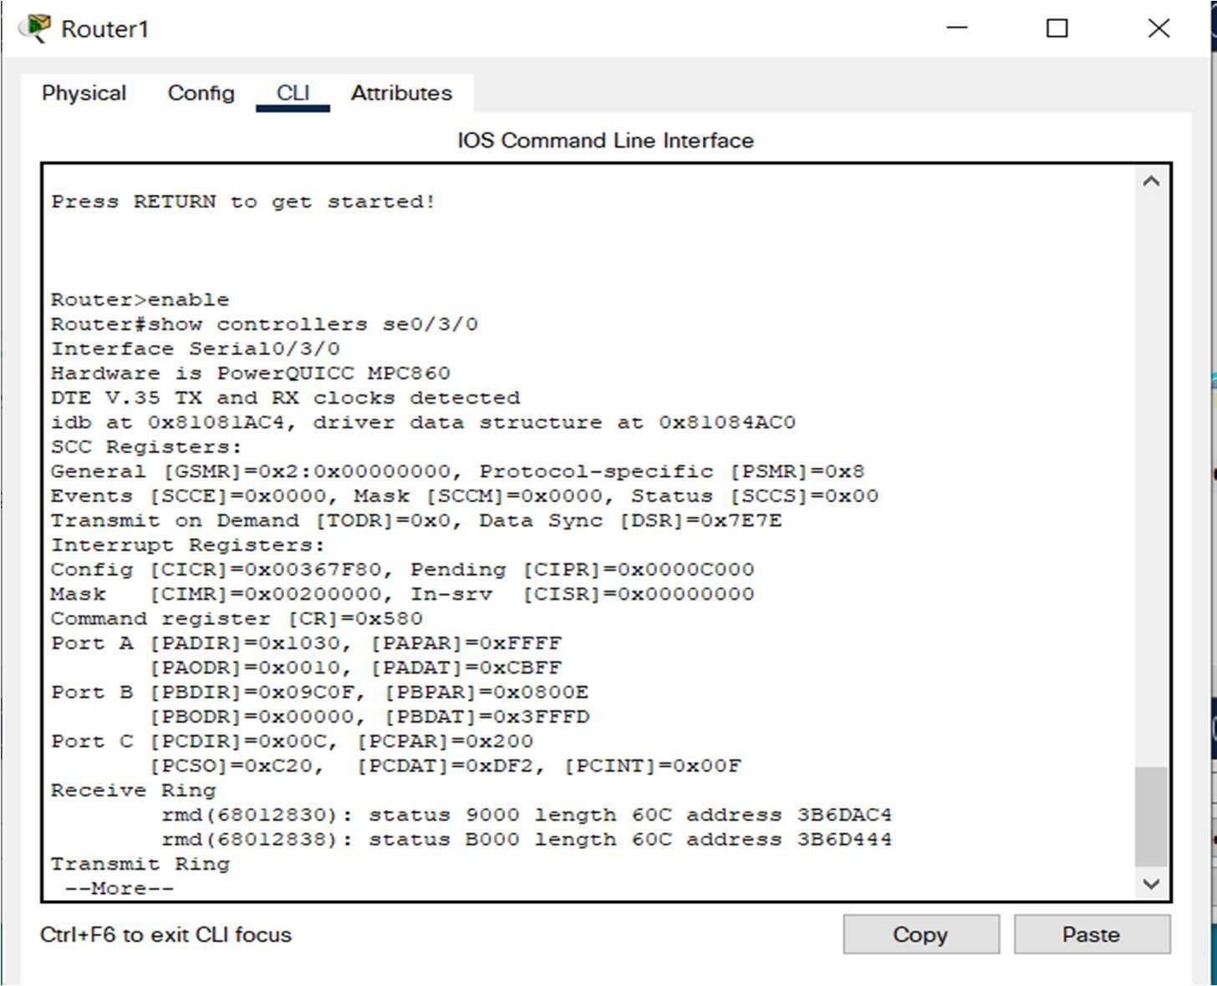

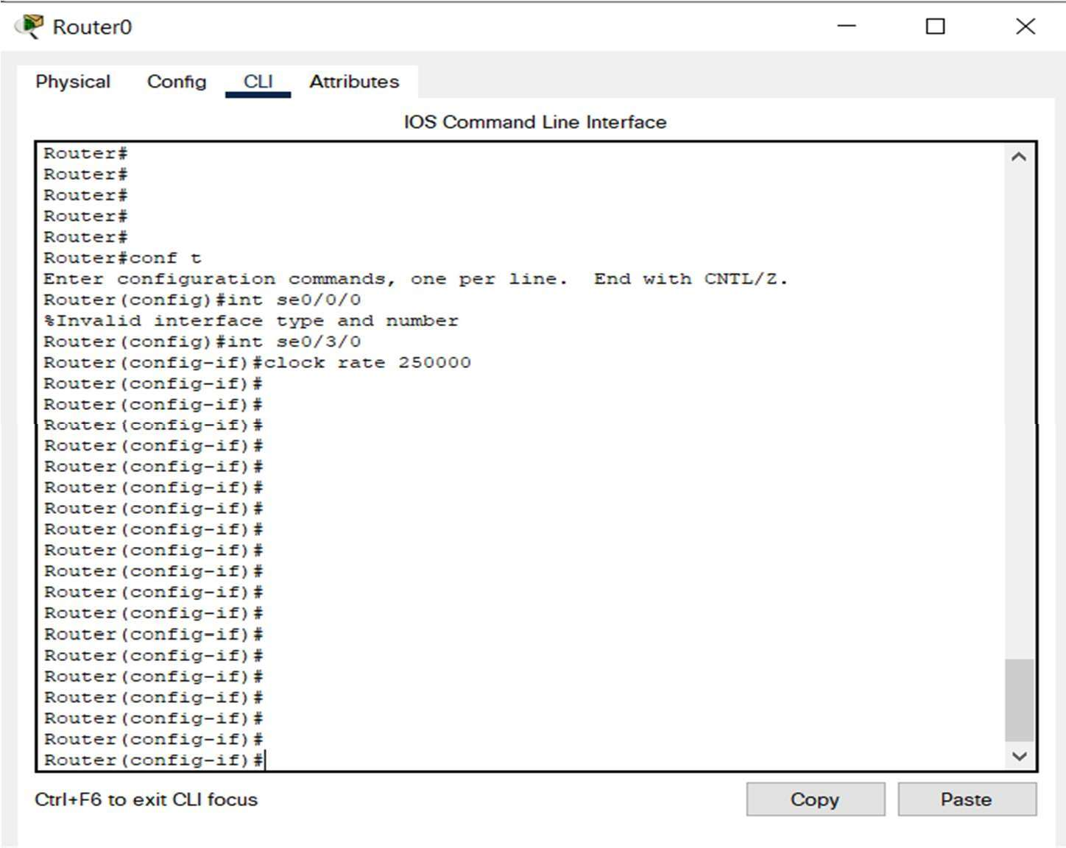

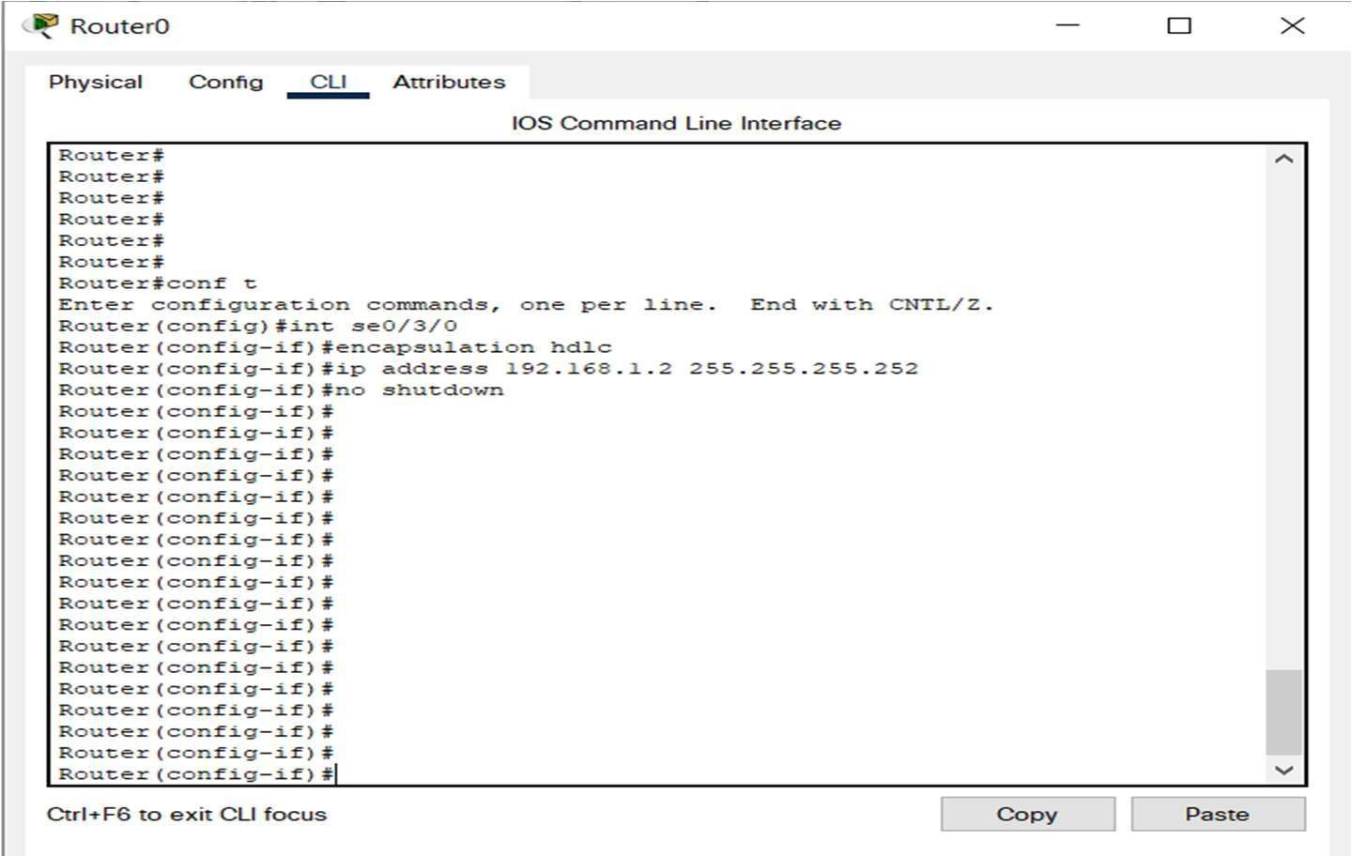

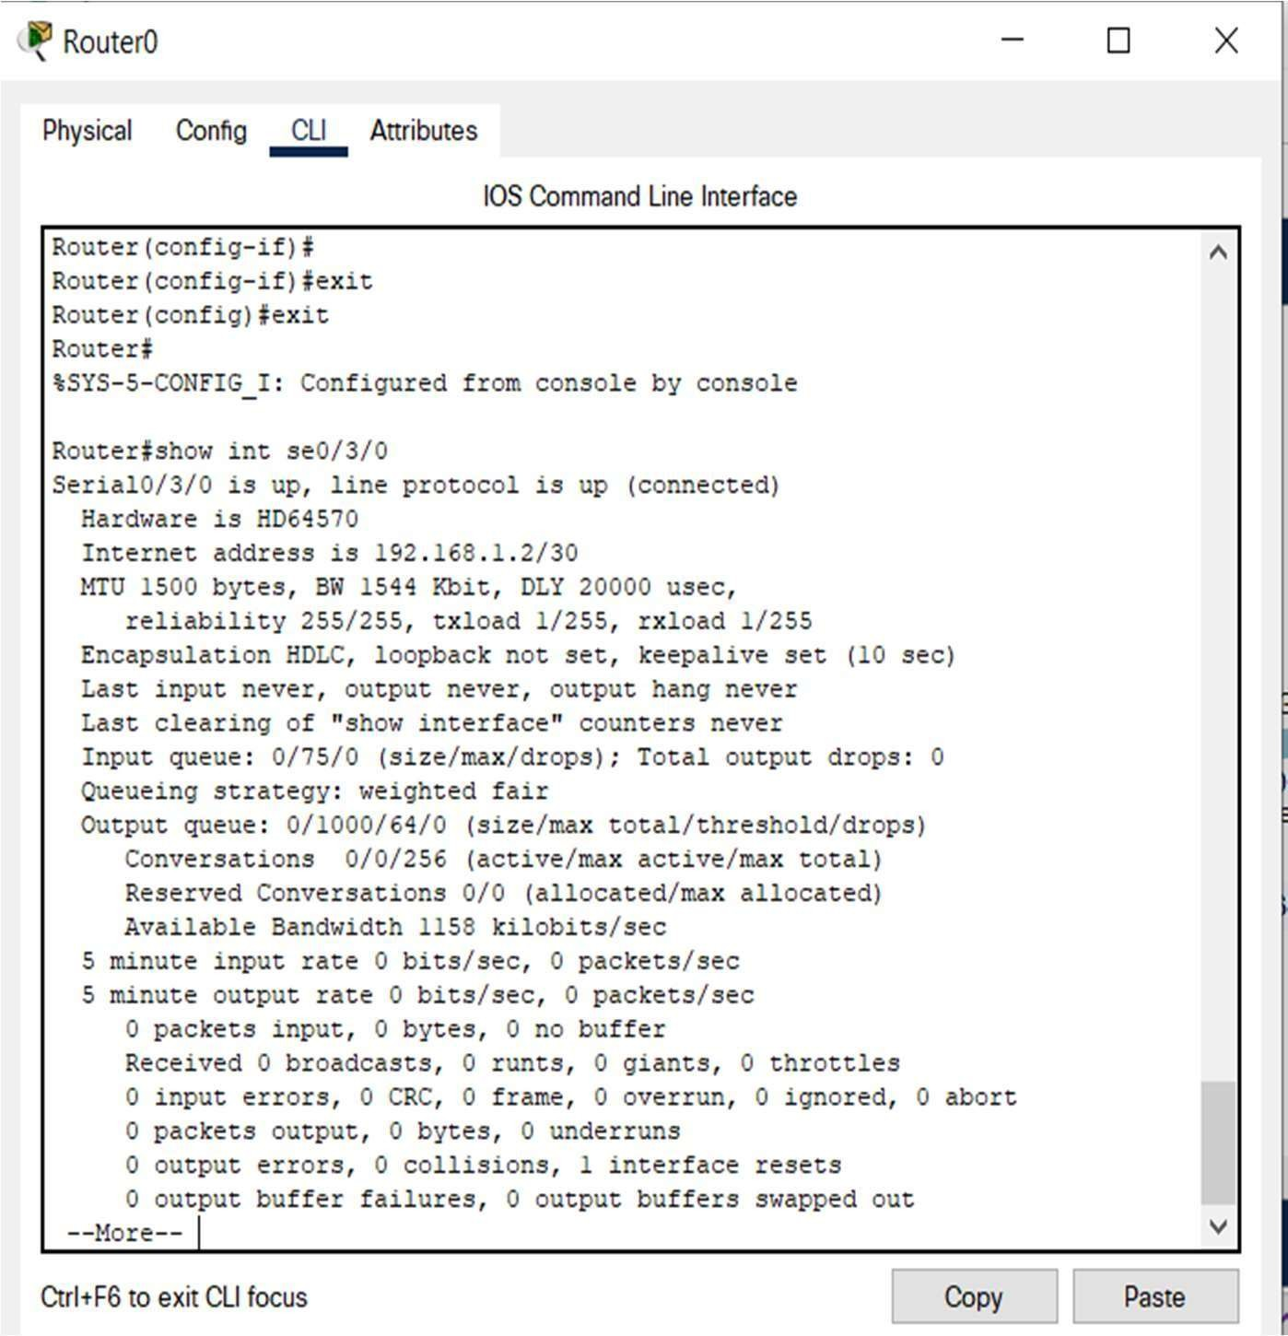



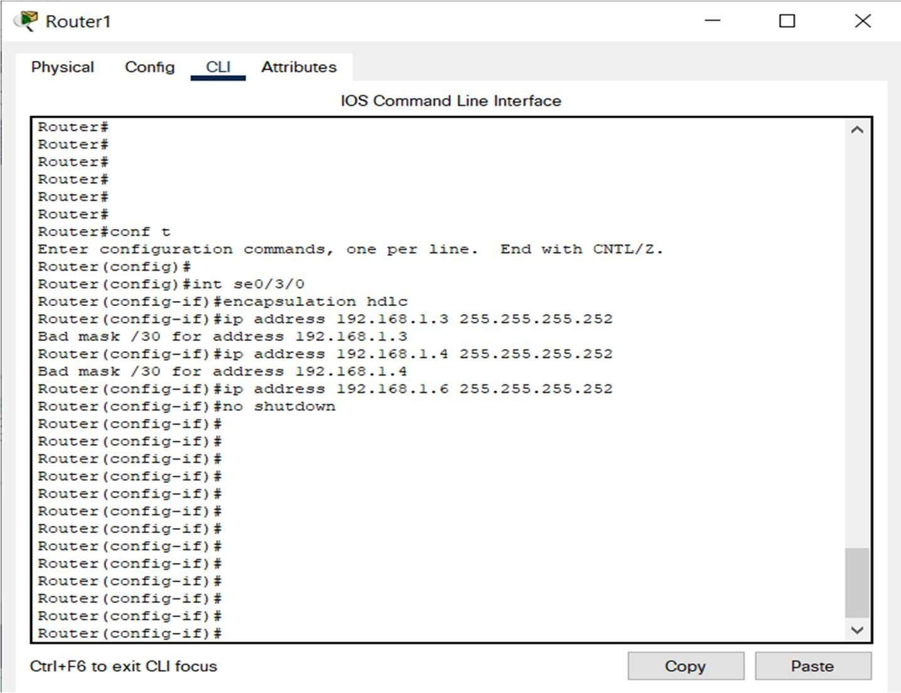

8.



Router#ping 192.168.1.6

Type escape sequence to abort.

Sending 5, 100-byte ICMP Echos to 198.168.1.6, timeout is 2 seconds:

!!!!!

Success rate is 100 percent (5/5), round-trip min/avg/max = 26/28/33 ms

Now we go to Router1 and test the network by pinging the Router0 interface.

Router#ping 192.168.1.2

Type escape sequence to abort.

Sending 5, 100-byte ICMP Echos to 192.168.1.2, timeout is 2 seconds:

!!!!!

Success rate is 100 percent (5/5), round-trip min/avg/max = 25/28/32 ms

**RESULT** :

|  |  |
| --- | --- |
| **Ex.No:15** | **COMMUNICATION USING HDLC** |
| **Date:** |

**AIM:**

**PROCEDURE:**

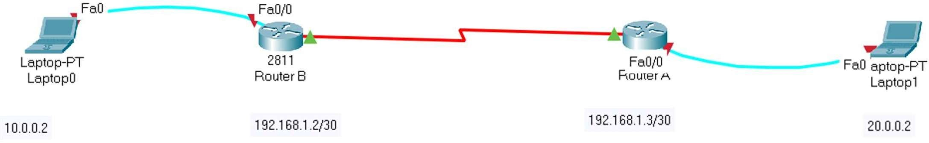

2 . Initial IP configuration.

|  |  |  |
| --- | --- | --- |
| **Device / Interface** | **IP Address** | **Connected with** |
|  |  |  |
|  |  |  |
|  |  |  |
|  |  |  |

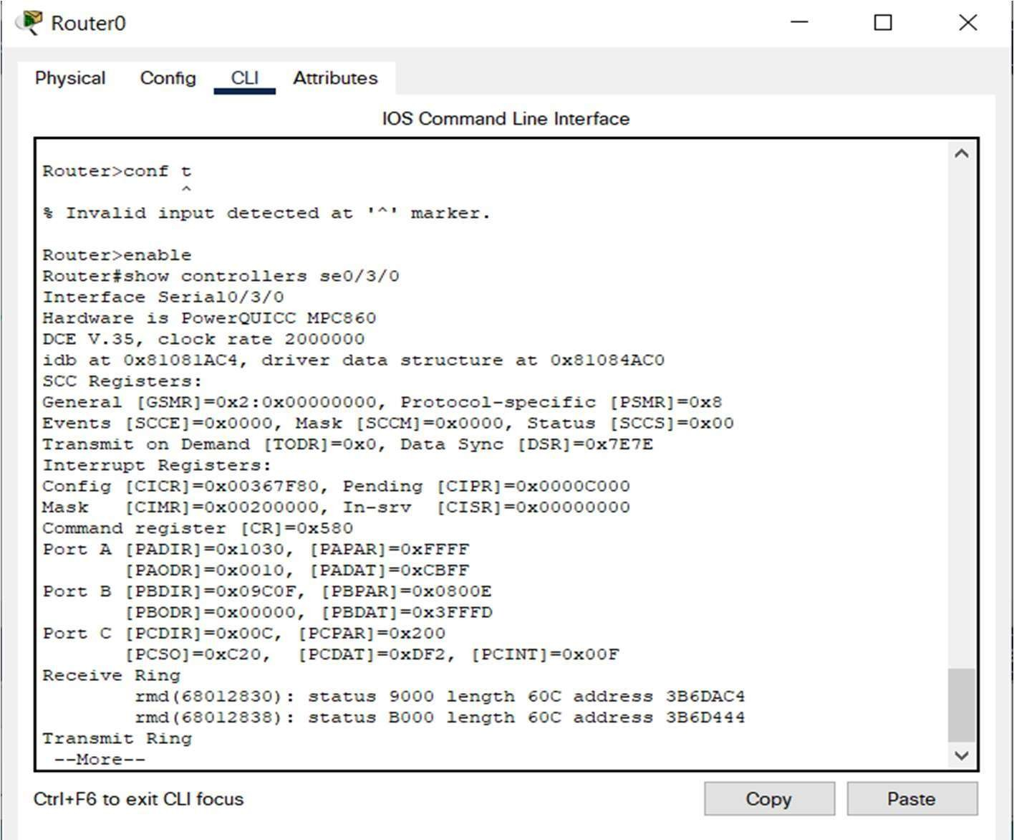

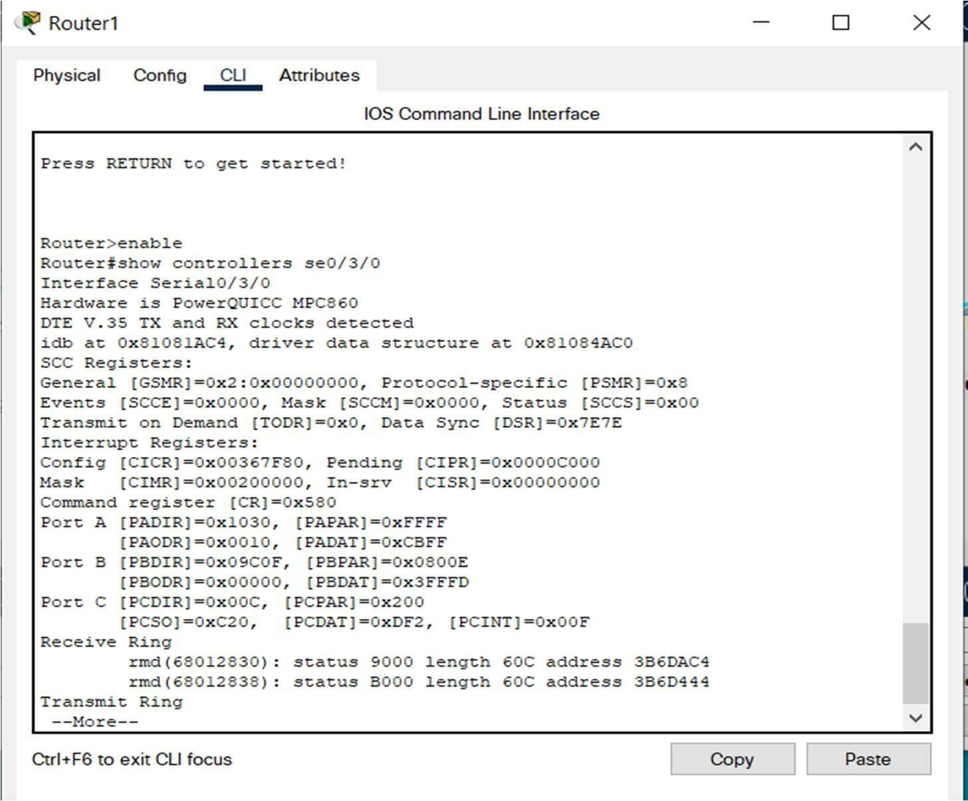

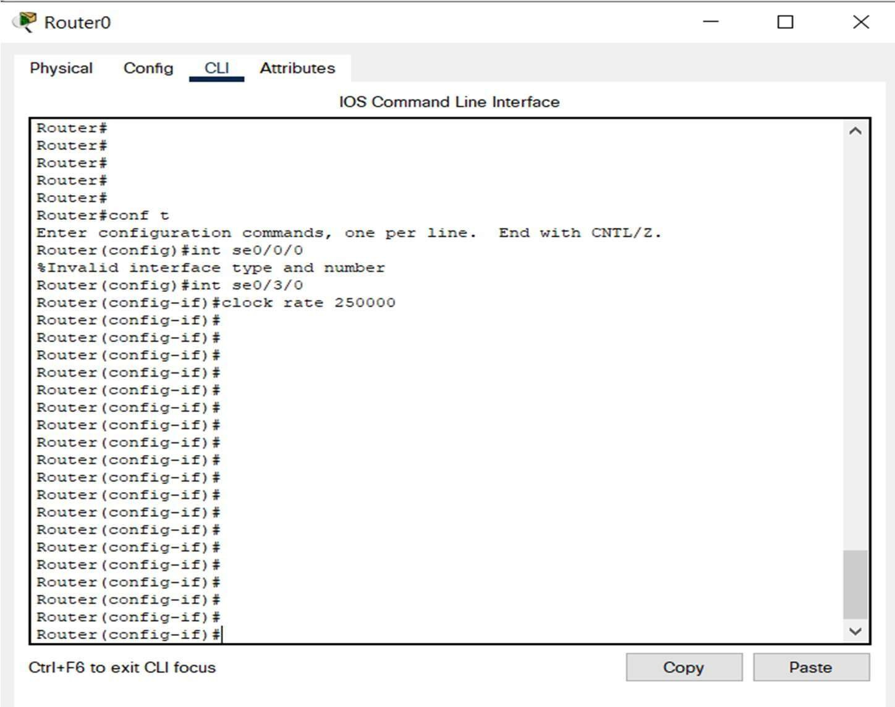

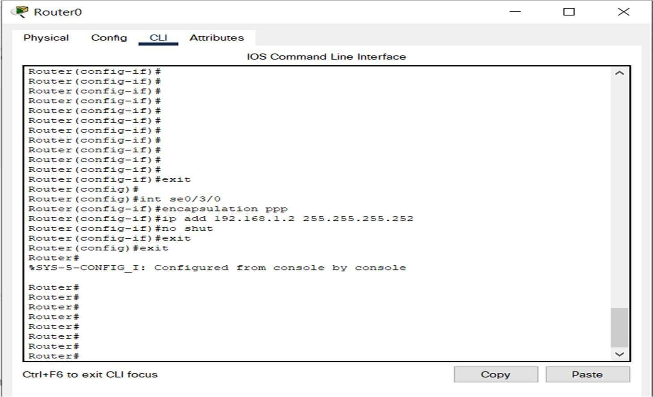

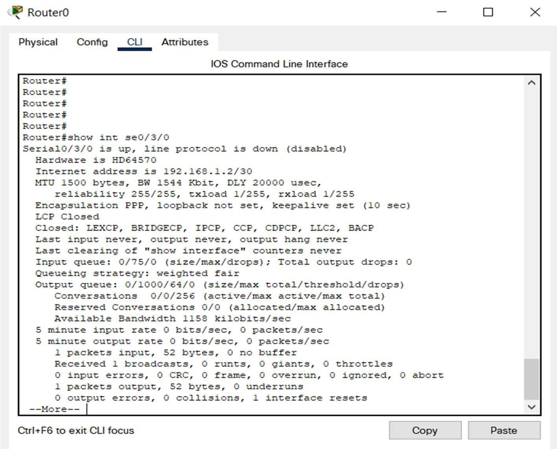

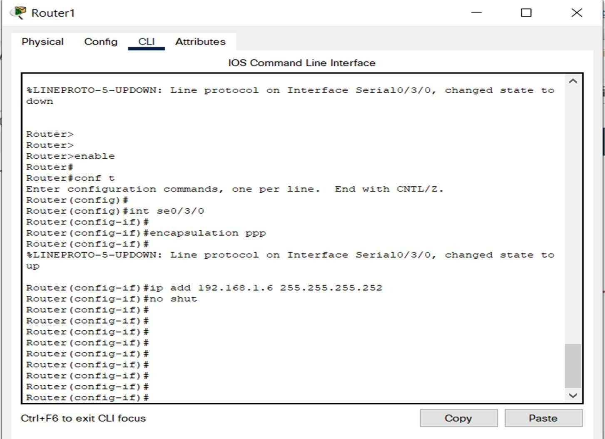

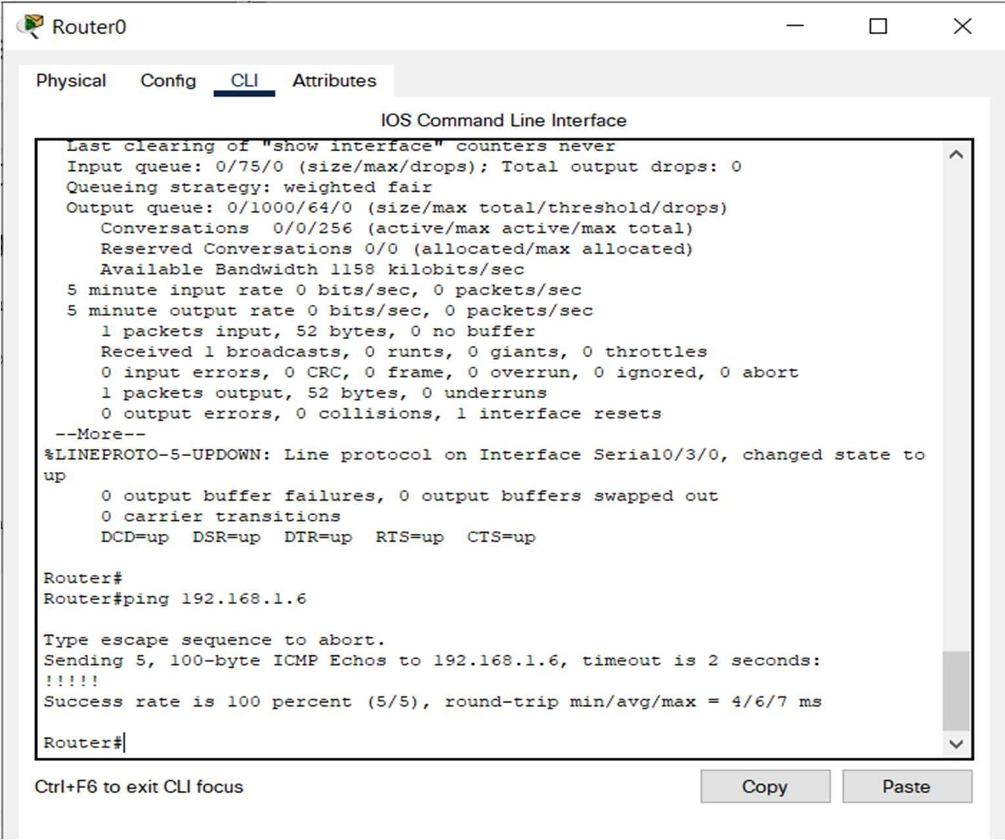

Now we go to Router1 and test the network by pinging the Router0 interface.

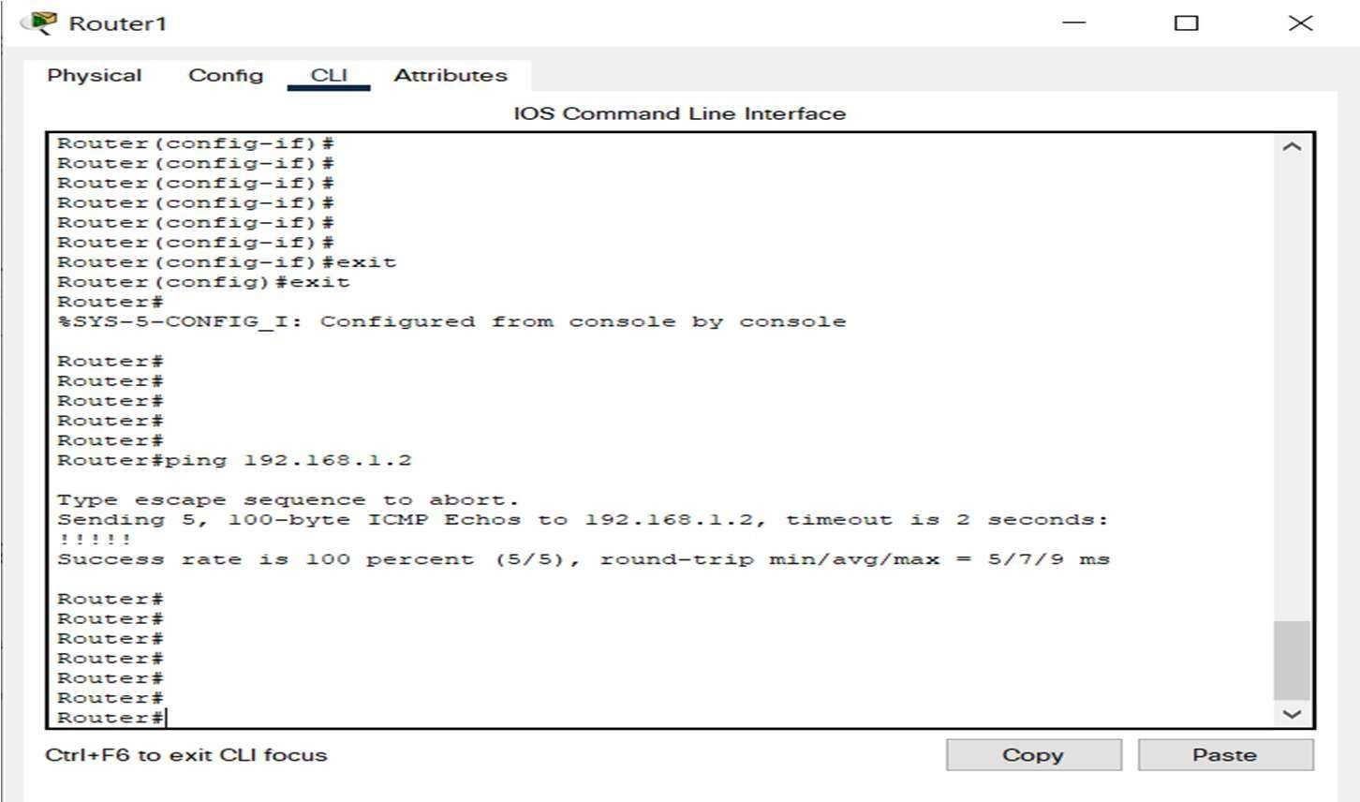

**RESULT:**